IMD 2015 – IDACI Deciles
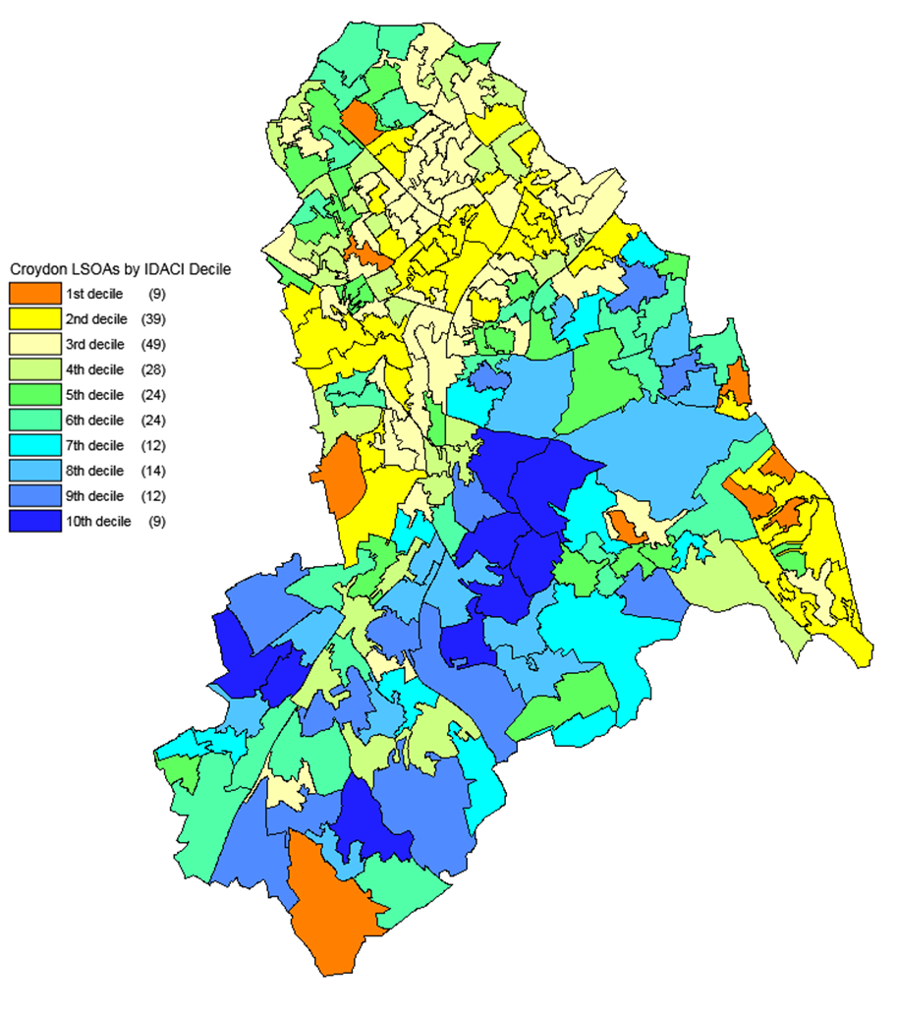
Source: DCLG and Ordnance Survey (Crown Copyright)

