IMD 2015 – Croydon LSOA Deciles
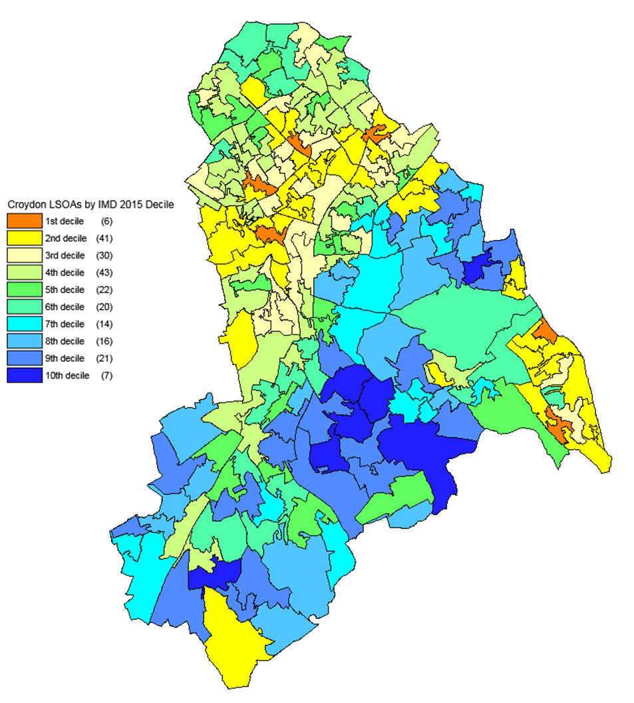
Source: DCLG and Ordnance Survey (Crown Copyright)

