IMD 2015 – Living Environment Deciles
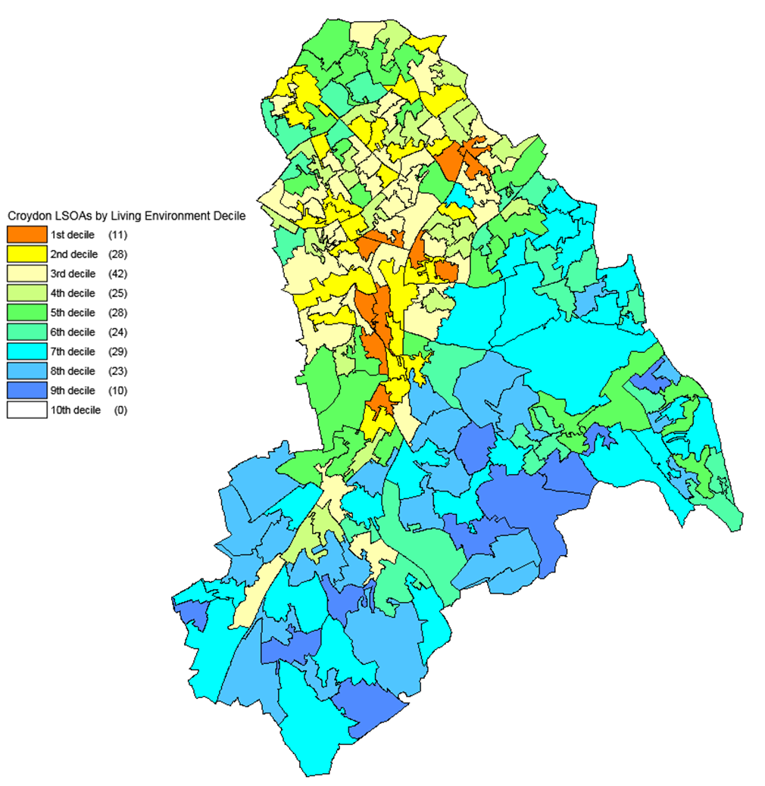
Source: DCLG and Ordnance Survey (Crown Copyright)

