IMD 2015 – Crime Deciles
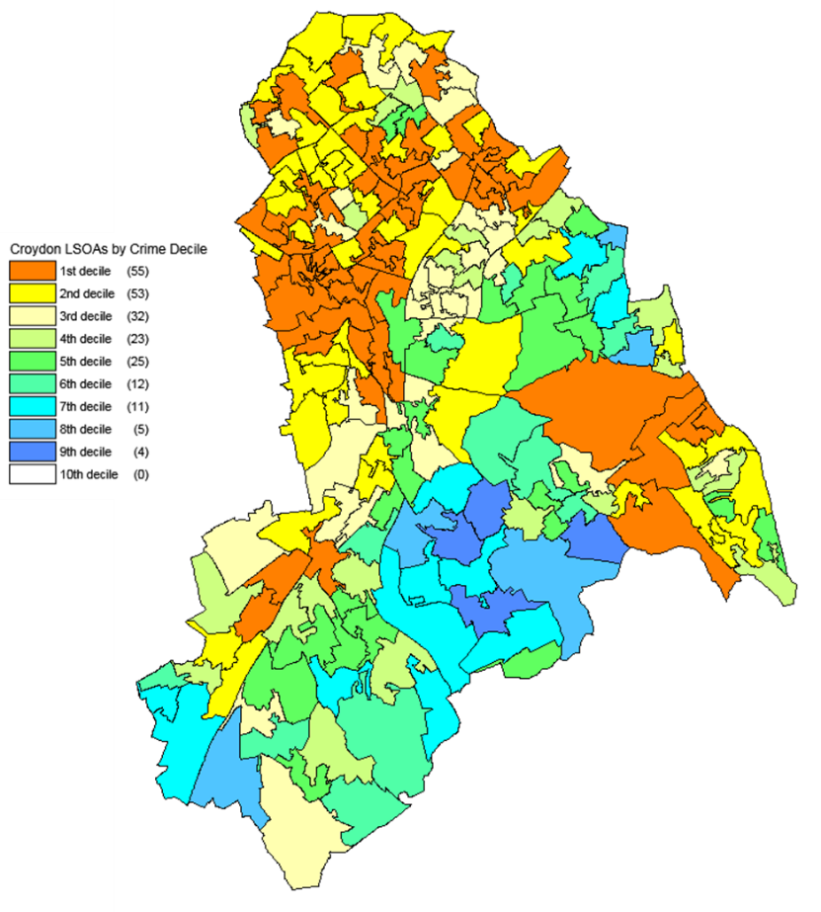
Source: DCLG and Ordnance Survey (Crown Copyright)

