**BOROUGH PROFILE December 2018**









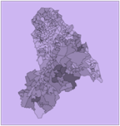

















**Contents**

Executive Summary 2

Population 12

Population growth 12

Our residents 14

Our communities 18

Deprivation 20

IMD - Overall changes since 2010 20

IMD 2015 Domains 23

Income Deprivation Affecting

Children Index (IDACI) 2015 30

Income Deprivation Affecting

Older People Index (IDAOPI) 2015 31

Education and skills 32

Early Years 32

School attainment 33

Further education 36

Economy 38

Businesses 38

Employment 40

People out of work 42

Apprenticeships 43

Skill levels of adults 44

Housing 46

Tenure 46

Cost of property 48

Availability of housing 50

Homelessness 51

Health 53

General health 53

Children and young people’s health 55

Adult’s health and lifestyle 59

Disease and poor health 60

Life expectancy and cause of death 64

Social care 67

Children in need 67

Looked after children 70

Adult safeguarding 75

Adults receiving care 76

Community safety 80

Total notifiable offences 80

MOPAC 7 81

Gang crime and serious youth violence 86

Knife crime 87

Hate crime 88

Domestic abuse and sexual violence 92

Antisocial behaviour 94

Youth offending 94

Adult and juvenile re-offending 94

Environment and transport 96

Environment 96

Transport 98

Fire Services 103

Fly-tipping 103

**Borough Profile 2018**

**Executive Summary**

This Borough Profile provides an overview of key information about the London Borough of Croydon and some of the issues facing both the communities in Croydon and service providers.

It is a good first reference point for intelligence about the Borough which can help those involved in commissioning and service provision on behalf of the Council. It also helps to inform other agencies not commissioned by the Council that provide services to Croydon residents.

As data throughout this document is available at different times of the year, it is intended that this will be updated at least twice a year.

Any feedback on this document should be addressed to Edmund Fallon, Senior Corporate Intelligence Officer, via email : [Edmund.Fallon@croydon.gov.uk](mailto:Edmund.Fallon@croydon.gov.uk)

.

The information is organised under the following sections:

* Executive Summary
* Population
* Deprivation
* Education and skills
* Economy
* Housing
* Health
* Social Care
* Community safety
* Environment and Transport

** Population**

**✓ Areas of progress**

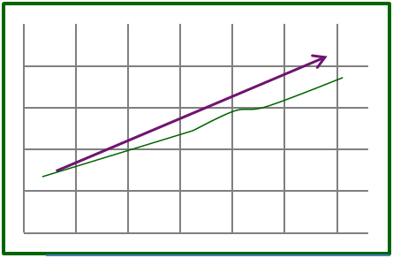

The Croydon population continues to grow steadily.

**Warning 2.png Challenges**

The higher birth rate in 2012 brought added pressures to provide for an increasing younger children population in the borough. The 2017 birth figure is close to the 2012 level.

**Injured man.png**

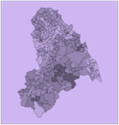 **Deprivation**

**✓ Areas of progress**



Under the Education, skills and training domain, Croydon ranked 220 out of 336 district authorities where 1st rank is most deprived and 336th rank is least deprived.

**Warning 2.png Challenges**

Croydon became relatively more deprived compared to other local authorities in England between 2010 and 2015.



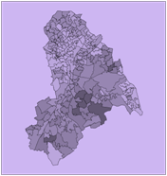

There remains geographic inequality in the distribution of deprivation in the borough with the north and east of the borough remaining more deprived.

Croydon was in the 25 most deprived district authorities in the country for the crime domain in the IMD 2015.



** Education and skills**

**✓ Areas of progress**

Levels of authorised absences as well as permanent exclusions from primary and secondary schools in Croydon are lower than the regional and national average rates.

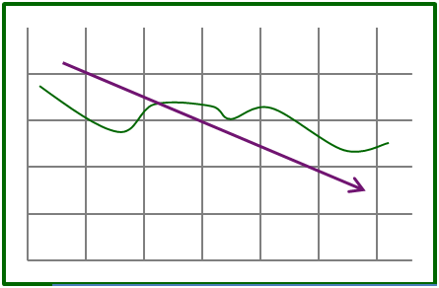

**Free School meals**

The gap between attainment of a qualification at level 2 with English and Maths by age 19 years between those not eligible for FSM and those eligible for FSM is the lowest it has been for 9 years.



**Warning 2.png Challenges**

Take up of funded hours in Early Years settings is still below regional and national averages.



**KS2**

Attainment at Key Stage 2, though improving in Croydon, is still a concern.

The proportion of pupils achieving grades AAB or above at Key Stage 5 is still much lower than the regional and national averages.

**KS5**

** Economy**

**✓ Areas of progress**

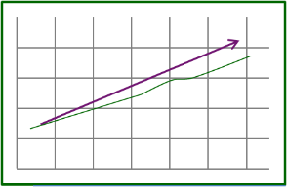

The number of businesses continues to grow.

The proportion of out of work claimants has been going down every year for the last 5 years.



Latest figures show that the proportion of out of work claimants in Croydon is lower than both the London and England averages.



**Warning 2.png Challenges**

**0.59**

The job density in Croydon remains low.

.

** Housing**

**✓ Areas of progress**

Croydon remains one of the most affordable areas to live in London both to buy and to rent.

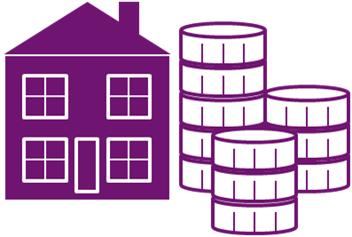

Croydon had the second highest number of net additional dwellings in 2016/2017.



**Warning 2.png Challenges**



The number of homeless acceptances, though lower than the previous 2 years, remains high.

The number of homeless households in temporary accommodation remains high and in excess of 2,000.





5th highest proportion of long-term vacant dwellings to total dwellings in London.

** Health**

**✓ Areas of progress**

Breastfeeding prevalence at 6-8 weeks remains higher than the national average.



The percentage of adults smoking in Croydon continues to fall and is below the national average.





Life expectancy at birth for men and women continues to increase.

The percentage of full-term babies with a low birth weight is in line with the national average.



**Warning 2.png Challenges**



Vaccination coverage remains low for a number of child and adult vaccinations.



The teenage conception rate in Croydon is still one of the highest in London.



Excess weight in pupils in Year 6 remains higher than the national average.

.



The rate of injuries due to falls in over 65s also remains higher than the regional and national averages.

** Social Care**

**✓ Areas of progress**

cid:image001.jpg@01D4A420.35F9D060

Croydon has dropped down from one of the highest rates of domestic abuse per 1,000 population to the top third of all London Councils.



The number of unaccompanied asylum seeking children has fallen every year for the last 3 years.

**Warning 2.png Challenges**



The rate of referrals to children’s social care is now higher than both the regional and national averages.

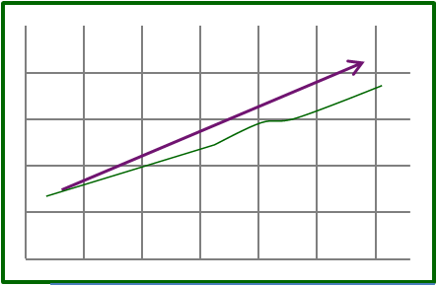

The number of looked after children in Croydon is still the highest in London.

** Community Safety**

**✓ Areas of progress**

The total number of notifiable offences in Croydon has fallen in recent years and the rate of offences committed in Croydon is lower than the London average.



The number of gang flagged offences has decreased but there remains an issue around public perception of this issue.



**Warning 2.png Challenges**



Knife crime is still an issue with around 30% resulting in injury or death.



The number of victims of serious youth violence is increasing.

** Environment and transport**

**✓ Areas of progress**



Carbon dioxide emissions continue to fall.



Croydon has one of the highest rates for the reuse, recycling and composting of household waste in London.

**Warning 2.png Challenges**

Uptake of cycling in Croydon is still below the averages in London and nationally with only 7.6% of residents estimated to have done cycling once a week during 2016/2017.





The number of road traffic collisions in Croydon in 2017 has been increasing over the last 3 years.



The number of people killed or seriously injured in road traffic accidents has increased significantly in 2017 compared to the previous 4 years.

seriously injured in road traffic collisions in Croydon has decreased since 2012.

** Population**

Areas of progress

* Croydon’s population continues to grow steadily.

Challenges

* The higher birth rate a few years ago means that there is an increase in the number of younger children requiring services in the borough.
* ONS MYE 2016 indicates that Croydon has a greater proportion of population aged 0-17 years compared to London and England and this will have an impact on school place provision.

**Overview**

This section offers a brief overview of the Croydon population looking at:

* Population growth
* Our residents
* Our communities

**Population growth**

**Overview**

Croydon’s population is growing. The borough population recorded in Census 2001 was 330,587 and in the 2011 Census it had increased to 363,378 (9.9%). Based on ONS mid-year estimates for 2017, Croydon is home to 384,837 people and this is expected to increase to just under 500,000 by 2050. Croydon is now the second most populous London borough, behind Barnet.

Figure 1 – Projected population growth in Croydon

Source: GLA Central Trend-based projections, 2016

Figure 2 provides a picture of the age profile in Croydon.

The latest ONS Mid-year estimate (MYE) indicates that 1 in 4 residents (24.6%) is aged between 0-17 years in Croydon. This is a higher percentage than both across London and nationally.

In London there is a higher proportion of people in the 20-39 year age group compared to Croydon. This can probably be explained by the fact that London is a working capital and this cohort are the younger, more mobile workforce in the prime years of their careers.

Figure 2 – Age Profile in Croydon

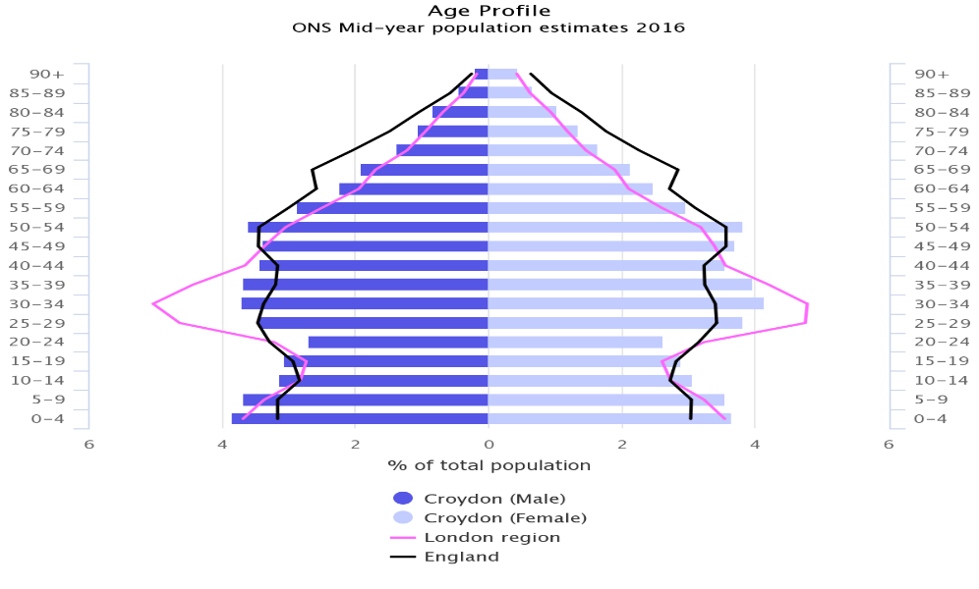Source : PHE Profile and ONS, MYE, 2016

**Births and deaths**

The number of live births in Croydon rose dramatically from just over 5,200 a year in 2009 to around 5,900 in 2012. Despite a drop to 5,600 in 2013, the annual birth numbers gradually rose each year, from 2013-2016. The latest figure for 2017 has seen a reduction to a similar level as 2011 at 5,761.

Latest figures (ONS Live births : country of birth of mother and area of usual residence‚ 2017) show that Croydon has a higher proportion of mothers who were born outside of the UK (52.1%) compared to the national average (29.2%). However, the London average across London is higher than in Croydon (57.9%).

In the last 10 years the life expectancy from birth in Croydon has progressively increased. For males the life expectancy from birth has increased from 77.4 years in 2004-2006 to 80.3 years in 2014-2016; similarly life expectancy from birth for females has increased from 81.2 years to 83.6 years over the same period.

There were 2,287 deaths in Croydon in 2013 which steadily peaked to 2,578 in 2015 to again drop in 2016 to 2,424. The latest 2017 figures show that deaths in Croydon have gone up again to 2,518. However, there has still been a net population increase over this period.

**Migration**

Based on the latest figures for 2016, domestic migration has had little impact on the growth of the Croydon population. 20,700 people moved into the borough whilst 23,700 people left the borough to go to other areas of the UK.

The international inflows into Croydon continue to exceed the international outflows and this results in more migrants from outside the UK. For 2016, the ONS has estimated that around 11% of the Croydon population is made up of members from the EU and about 8% come from the rest of the World.

The increase in international inflows in Croydon could be due to Croydon being home to a Borders Agency (Home Office) which would encourage more migrants to the borough.

Figure 3 – International migration flows

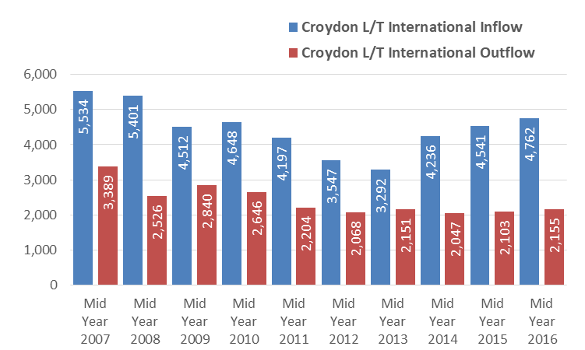

Source: ONS Migration statistics.

**Our residents**

**Ethnicity**

Croydon has a diverse population. As with other London boroughs Croydon has a higher proportion of residents from black and minority ethnic (BME) backgrounds than the national average. Figure 4 clearly shows that the younger population was more diverse than the older population in Croydon in 2011.

Figure 4 – Ethnic group by age

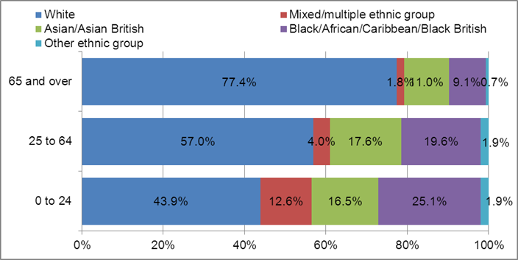

Source: ONS 2011 Census

Table 1 shows more up to date demographic projections from the GLA. Based on these, the proportion of Asian and Black residents in Croydon has been increasing since the 2011 Census. The proportion of White population is predicted to decrease by almost 10% by 2021. It will be interesting to see whether the 2021 Census will confirm all the ethnic proportions forecast by the GLA’s 2015 projections.

Table 1 – Croydon Ethnic Group Profile

|  |  |  |  |  |  |  |
| --- | --- | --- | --- | --- | --- | --- |
| **Ethnic Group / Year** | **2011** | **2017** | **2018** | **2019** | **2020** | **2021** |
| **White** | 55% | 49% | 48% | 48% | 47% | 46% |
| **Mixed** | 7% | 8% | 8% | 8% | 8% | 8% |
| **Asian** | 16% | 19% | 19% | 19% | 20% | 20% |
| **Black** | 20% | 23% | 23% | 23% | 24% | 24% |
| **Other** | 2% | 2% | 2% | 2% | 2% | 2% |
| **TOTAL** | 100% | 100% | 100% | 100% | 100% | 100% |

Source : GLA 2015 Projections, long-term migration scenario.

**Age and Gender**

Croydon has the largest population of young people in London. As can be seen from Figure 5 there is a large population of younger children and working age adults in Croydon. The proportion of residents aged 65 and over is much lower than the national average.

Figure 5 – Croydon Age and Gender Profile

Source : ONS, 2016-based subnational population projections

**Religion**

Just over half of respondents to the 2011 Census in Croydon stated that they were Christian. About 1 in 5 stated that they had no religion. Significantly 7.6% of respondents did not state their religion.

Figure 6 – Religion of Croydon residents

Source: ONS Census 2011 Table KS209EW

**Sexual orientation**

Sexual orientation was not captured by the 2011 Census. The ONS produce regional estimates of the percentage of the population who identify themselves as gay, lesbian or bisexual. Across London it is estimated that 2.6% of the population in 2014 identified themselves as gay, lesbian or bisexual, higher than the national average of 1.6%.

By applying the London average to the Croydon population it is estimated that there would have been around 9,800 people in Croydon in 2014 who would have identified themselves as gay, lesbian or bisexual.[1]

**Gender identity**

Data on the gender identity is not routinely captured. Gender variance is when someone believes he/she is a different gender to the one he/she had at birth. This condition is thought to begin before birth and can be experienced to different degrees. The Gender Identity and Research Society (GIRES) has estimated that nationally 1% of the population may be gender variant to some degree and 0.2% of the population is likely to seek medical treatment to present in the opposite gender.[2]

**Marital status**

The 2011 Census is the latest data source for marital status. As Figure 7 shows the majority of adults aged over 16 in Croydon were either married or single in 2011.

Figure 7 – Marital status of Croydon residents

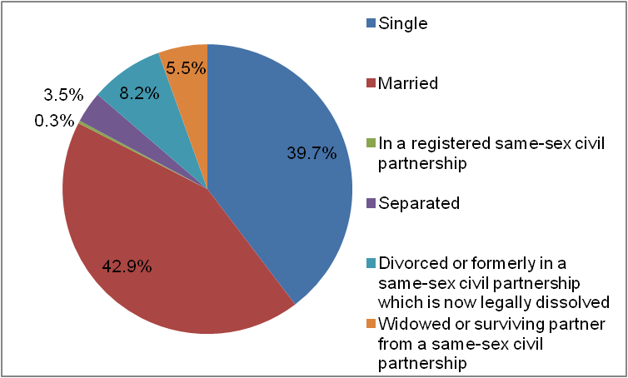

Source: ONS Census 2011 Table KS103EW

**Disability**

There is not one comprehensive figure that can give a true picture of the total number of people with a disability in Croydon.

The 2011 Census figures showed that 14.1% of the population in Croydon had their day-to-day activities limited to some extent by a long-term health problem or disability. 22,493 people had their day-to-day activities limited a lot, whilst 28,134 had their day-to-day activities limited a little.

Figure 8 – Proportion of people whose day-to-day activities were limited by a long-term health problem or disability

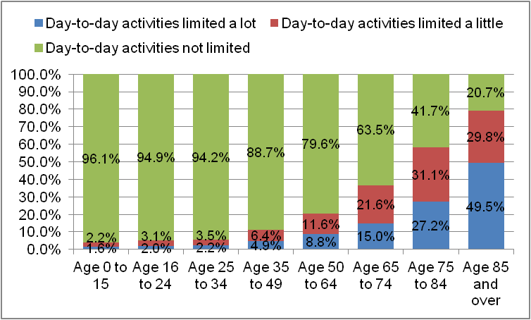Source: ONS 2011 Census Table DC3302EW

**Our communities**

Croydon is home to a diverse range of communities as can be seen from the map, (Figure 8) below.

The 2011 Output Area Classification (OAC) which the map depicts uses 2011 Census data to identify areas with similar demographic characteristics.

Overall the OAC shows that the north of the borough is more culturally diverse and is more similar to other London areas. The south of the borough has more in common with more rural areas such as neighbouring Surrey.

Figure 8 – Map of OAC groups in Croydon

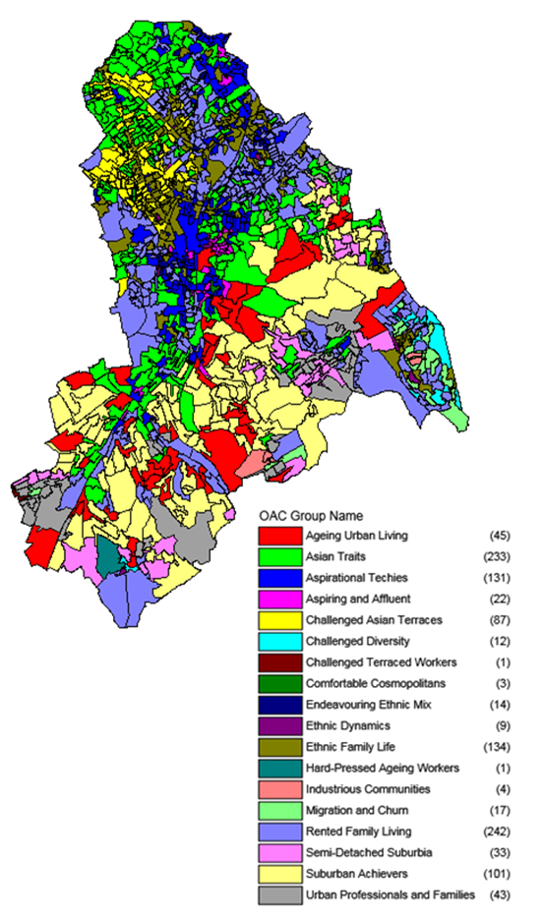

Source: ONS 2011 Census.

**Proficiency in English**

In the 2011 Census 14.5% of people in Croydon had a language other than English recorded as their main language. The majority were recorded as speaking English well or very well. However 17.2% (2.5% of the total population) were recorded as being unable to speak English well or being unable to speak English.

Only 5.4% of 8 to 9 year olds with English as an additional language were unable to speak English well or were unable to speak English at all. These children made up only 0.4% of all the 8 to 9 year olds in Croydon.

The proportion of people with English as an additional language who were unable to speak English well or unable to speak English increased with age. Over half (51.5%) of adults aged over 85 with English as an additional language were unable to speak English well or were unable to speak English. However, these adults made up only 2.9% of all over 85 year olds in Croydon.

The proportion of females with English as an additional language who were unable to speak English well or unable to speak English was slightly higher than for males, at 19.7% compared to 14.5%.

In the 2011 Census, the 3 wards of Broad Green, West Thornton and Norbury made up over a quarter of the people in Croydon unable to speak English well or are unable to speak English.

Coulsdon East was the ward with the lowest proportion (0.6%) of people unable to speak English well or at all. The national average was 1.7% and across London the average was 4.1%.

**Carers**

In Croydon 9.3% of the population provided some form of unpaid care in 2011 according to the Census, slightly higher than the regional average of 8.5%. This equates to 33,683 carers in Croydon. Of those 65.5% provided up to 19 hours of unpaid care a week. However, 20.3%, 6,870 people, provided 50 or more hours of unpaid care a week.

** Deprivation**

Areas of progress

* Croydon is the bottom third (220 out of 336 district authorities) least deprived under the Education, skills and training domain.

Challenges

* Croydon became relatively more deprived compared to other local authorities in England between 2010 and 2015.
* Although there have been some changes in the individual rankings of LSOAs within the borough there remains geographic inequality in the distribution of deprivation in the borough with the north and east of the borough remaining more deprived.
* Croydon was in the 25 most deprived district authorities in the country for the crime domain in 2015.
* Croydon was the 19th most deprived district authority in the country for barriers to housing and services.

**Overview**

This section looks at the Index of Multiple Deprivation (IMD) and its supplementary indices.

* IMD 2015 – Overall changes since 2010
* IMD 2015 Domains
* Income Deprivation Affecting Children Index (IDACI) 2015
* Income Deprivation Affecting Older People Index (IDAOPI) 2015

**IMD 2015 – Overall changes since 2010**

**Introduction**

The Index of Multiple Deprivation 2015 is a set of measures that allows relative deprivation levels across the country to be compared. It is formed of seven different deprivation domains:

* Income
* Employment
* Education, skills and training
* Health deprivation and disability
* Crime
* Barriers to housing and services
* Living environment

Each of these domains will be looked at in this section. There are also two supplementary indices : the Income Deprivation Affecting Children Index (IDACI) and the Income Deprivation Affecting Older People Index (IDAOPI). These look at the proportion of children and older people who are income deprived respectively.

It is important to note that the IMD will show the relative ranking of different authorities over time but it cannot indicate how much more deprived one authority is to another.

The index is based on data at Lower Layer Super Output Area (LSOA) level. LSOAs were created based on 2011 Census data by the Office for National Statistics (ONS). There are 220 LSOAs in Croydon and each one had between 1,000 and 3,000 people.

For each deprivation domain, each LSOA is given a score and ranked. Rank number 1 signifies the most deprived LSOA in the country. Local authority scores are provided based on the average score of all the LSOAs in each authority.

The rank of average rank is based on the average of the ranks for each LSOA in the authority. The extent of deprivation is a measure of how widespread the deprivation is across the authority. This is based on how many LSOAs in the area are in the top 30% most deprived LSOAs in the country. The rank of concentration compares the most deprived LSOAs in a local authority against those in other authorities across the country.

Tables 1 and 2 show that Croydon has become relatively more deprived across 3 of the 4 measures from IMD 2010 to IMD 2015.

Table 1 – Upper tier authority rankings (out of 152)

|  |  |  |
| --- | --- | --- |
| **Index Measure** | **IMD 2010** | **IMD 2015** |
| Rank of average rank | 70 | 64 |
| Rank of average score | 77 | 71 |
| Rank of extent of deprivation | 80 | 73 |
| Rank of concentration | 93 | 95 |

Table 2 – Lower tier authority rankings (out of 326)

|  |  |  |
| --- | --- | --- |
| **Index Measure** | **IMD 2010** | **IMD 2015** |
| Rank of average rank | 99 | 91 |
| Rank of average score | 107 | 96 |
| Rank of extent of deprivation | 114 | 98 |
| Rank of concentration | 134 | 134 |

Figures 1 and 2 show that between IMD 2010 and IMD 2015 the overall pattern of deprivation across the borough has remained quite similar.

Figure 1 – IMD 2010 deciles

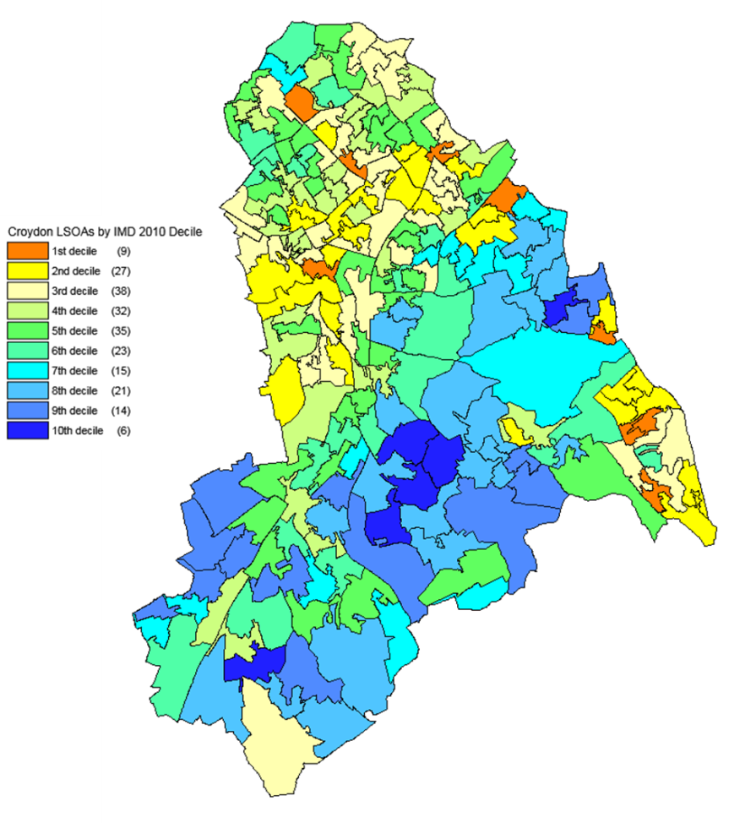

Source: DCLG and Ordnance Survey (Crown Copyright)

Figure 2 – IMD 2015 deciles

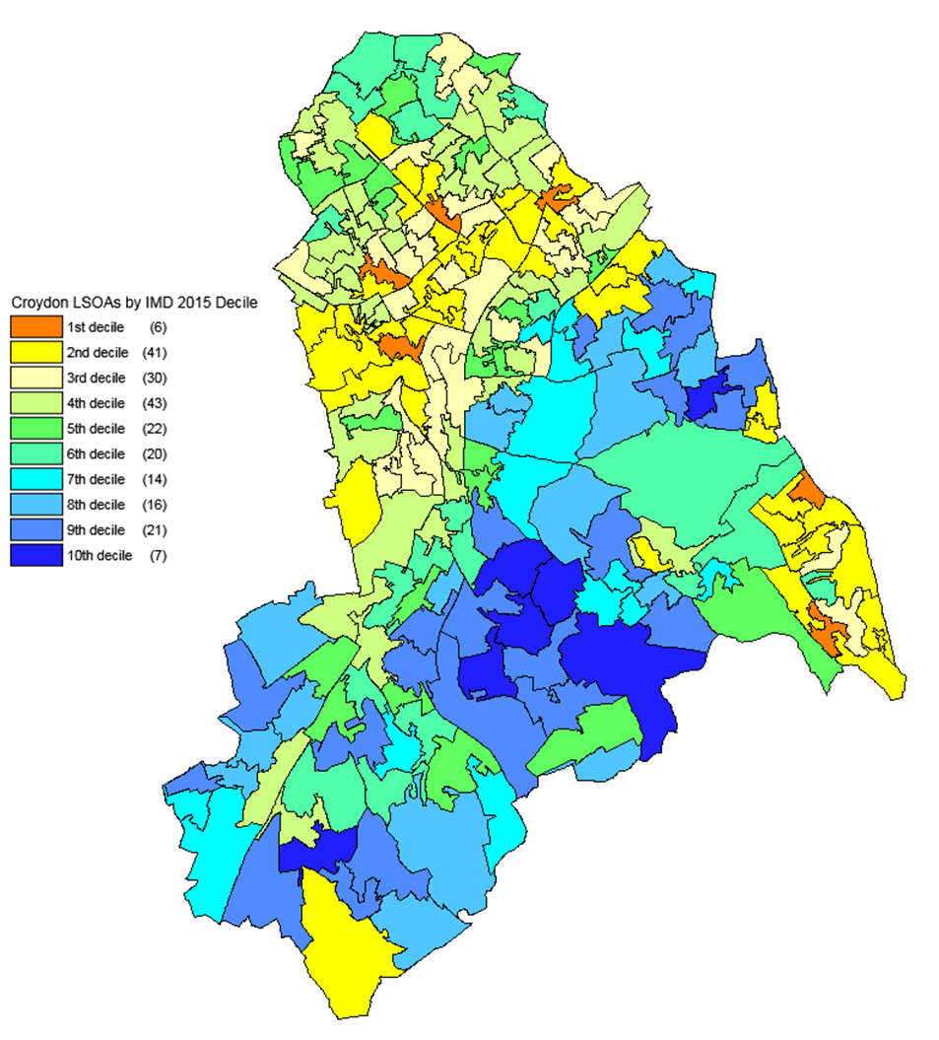

Source: DCLG and Ordnance Survey (Crown Copyright)

**IMD 2015 Domains**

**Income**

The Income domain looks at the proportion of the population who are either out of work or who have low earnings. It is based on a number of measures around people who are in receipt of income based benefits as at August 2012.

The score of each LSOA on the income domain contributes towards 22.5% of the LSOA’s overall deprivation score. The overall pattern of income deprivation across the borough mirrors that for overall deprivation.

Croydon has an average score of 0.162 for the income domain, which places it as the 90th most deprived local authority out of the 326 districts in England.

The orange areas are in the top 10% most deprived LSOAs in the country and together make up 5% of the total LSOAs in the borough. Figure 3 shows these are spread out across the borough.

There is still a noticeable north-south split with a sizeable number of the LSOAs (in blue) in the south with a lower proportion of people on lower incomes than in the northern parts of the borough.

Figure 3 – Income deciles

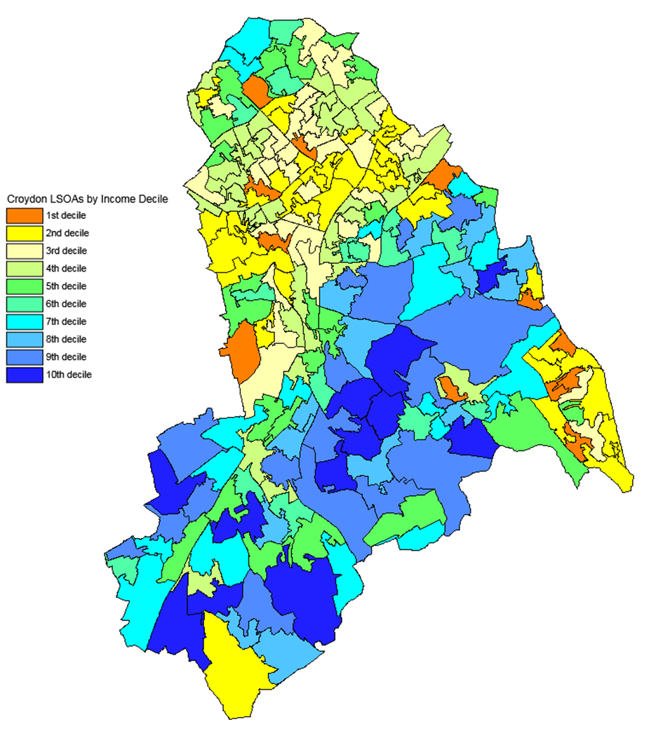

Source: DCLG and Ordnance Survey (Crown Copyright)

**Employment**

The Employment domain looks at the proportion of the labour market who are involuntarily excluded from working due to unemployment, sickness or disability, or caring responsibilities. The data for this is based on benefits data for the period 2012-13 and was adjusted to take into account seasonal variations in the number of claimants.

Figure 4 shows that there were fewer LSOAs in the top 10% most deprived areas in England for the employment domain than there are for the income domain but the pattern of deprivation across the borough remains broadly the same.

The average score for the Employment domain was 0.115, placing Croydon as the 133rd most deprived LSOA out of the 326 districts. Only just over 1% of LSOAs in Croydon were in the most deprived 10% of areas in England.

Figure 4 – Employment deciles

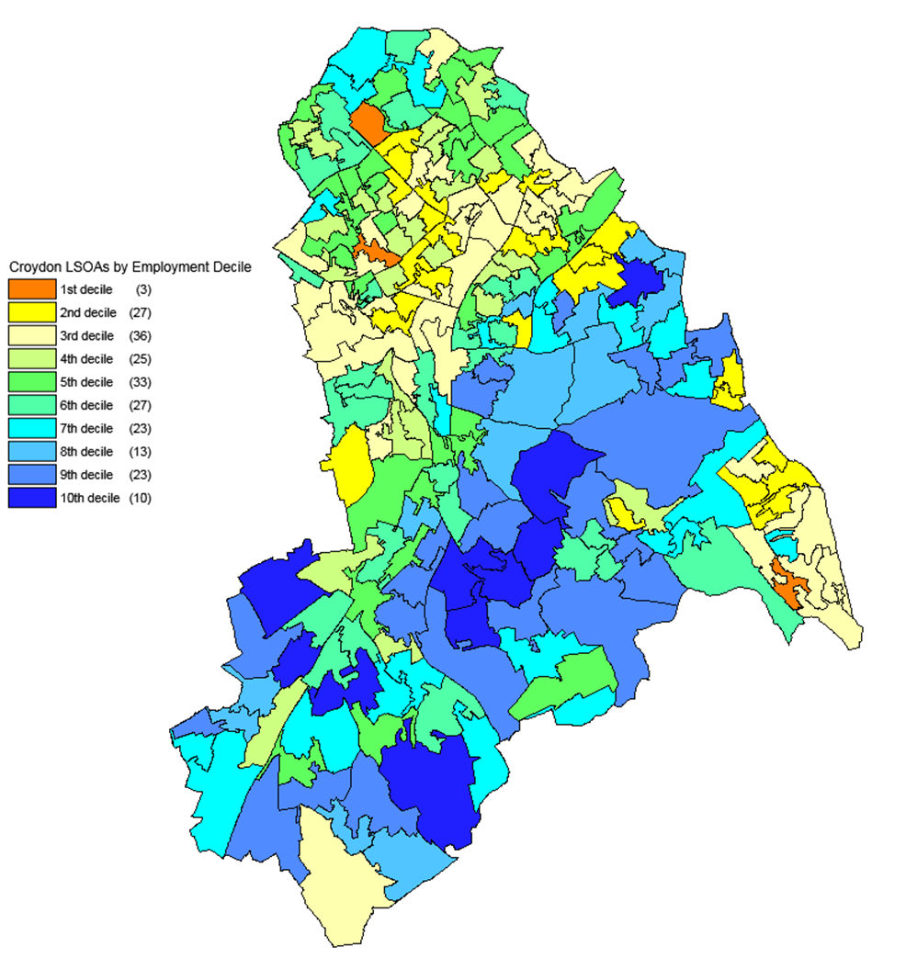

Source: DCLG and Ordnance Survey

**Education, skills and training**

The Education, skills and training domain looks at the lack of skills and attainment in the population. This includes the attainment and absence of pupils at school, the numbers of young people staying in education post-16, and the progression of young people on to higher education. It also includes the proportion of adults with no qualifications and the proportion of adults who are unable to speak English well.

The data on children and young people is based on three years’ worth of data, with the most recent data included dating from 2012/13. The data on adults was taken from the 2011 Census.

Croydon was in the bottom third of local authorities in the country for this domain; the average score for the borough was 15.661 making it the 220th most deprived borough out of the 326 districts. Just over 1% of the LSOAs in Croydon were in the top 10% most deprived areas in the country.

Areas in the north of the borough and the east are more deprived in this domain. In the east there are known issues around lower average attainment scores for pupils, and a higher proportion of adults with no qualifications.

Figure 5 – Education, skills and training deciles

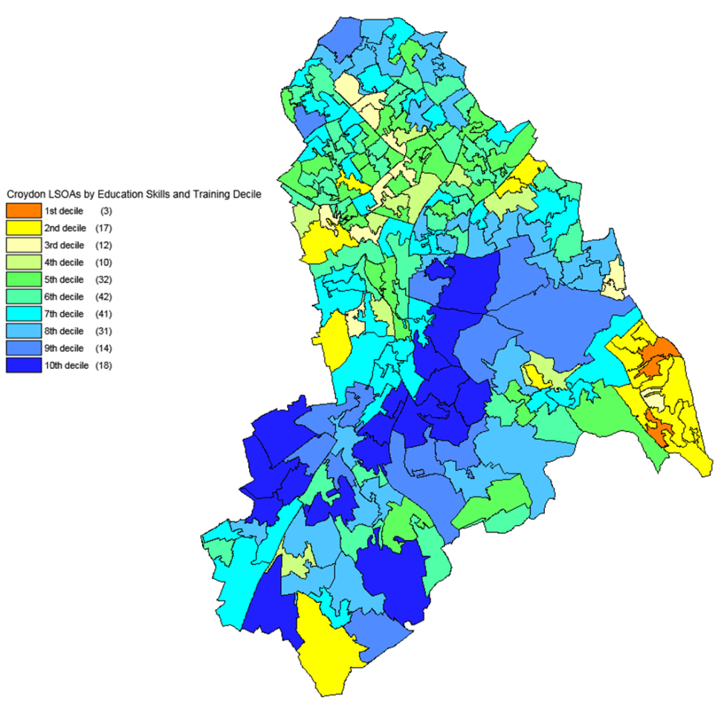

Source: DCLG and Ordnance Survey

**Health deprivation and disability**

The Health deprivation and disability is based on the risk of premature death and the impairment of quality of life due to poor mental or physical health. It is based on a range of different indicators covering different time periods. The most recent data used is from 2013.

The average score for Croydon for this domain was -0.134, making it the 155th most deprived authority out of the 326 districts. Again just over 1% of LSOAs were in the top 10% most deprived areas in the country.

Figure 6 shows the pattern of health deprivation and disability across the borough. Broadly the most deprived areas in Croydon in this domain are in the centre of Croydon, and in the east of the borough. These areas scored highly across each of the measures used for this domain.

Figure 6 – Health deprivation and disability deciles

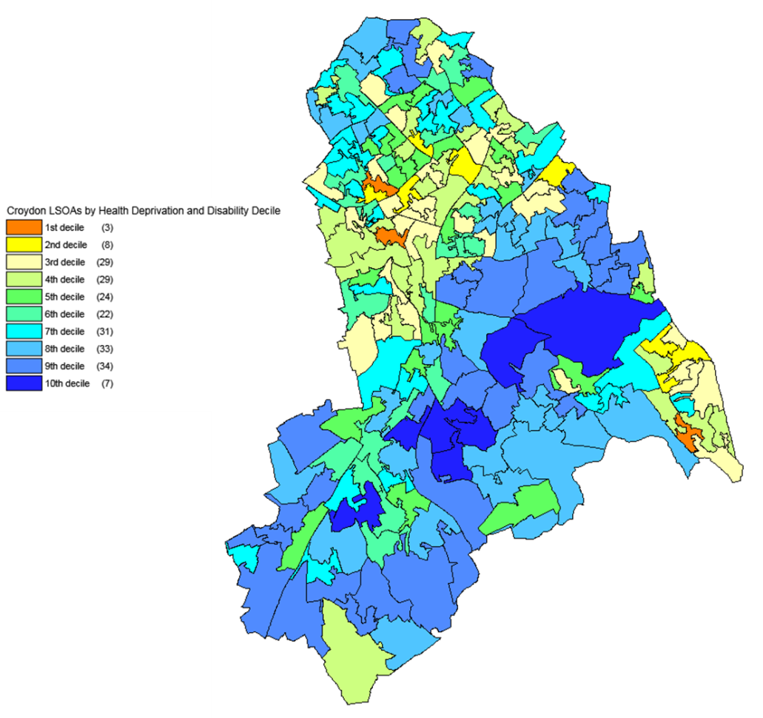

Source: DCLG and Ordnance Survey

**Crime**

The Crime domain is based on the rates of violence, burglary, theft and criminal damage per 1,000 at-risk population. This at-risk population is the count of the residents in the area plus the number of people who work in the area but are not resident there. The data are based on recorded crimes for 2013/14.

The average score in Croydon was 0.624 making it the 22nd most deprived authority out of the 326 districts. In fact, 13 of the 33 London boroughs were in the top 25 most deprived authorities in the country and 30 were in the top third. This is not surprising as crime rates in London and other urban areas are higher than in many more rural parts of England.

25% of LSOAs in the borough were in the top 10% most deprived areas in the country. These LSOAs were predominantly in the north and centre of the borough as can be seen from Figure 7.

It should be noted that the number of total notifiable offences in Croydon is falling and that latest figures from MOPAC show that crime in London is falling at a faster rate than the national average.[3]

Figure 7 - Crime deciles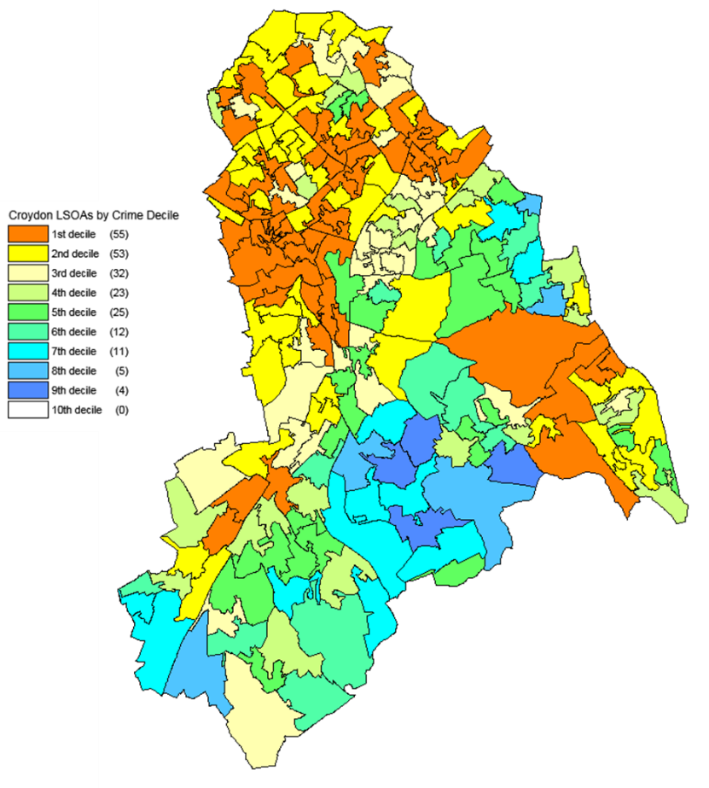

Source: DCLG and Ordnance Survey

**Barriers to housing and services**

The barriers to housing and services domain looks at geographical barriers to services and wider barriers. These barriers are based on the average distance to key services such as a GP surgery, primary school, post office, and a general store or supermarket based on data from 2014. The wider barriers include household overcrowding, homelessness and housing affordability.

The average score in Croydon was 31.671, ranking Croydon the 19th most deprived authority out of the 326 districts. 15 of the 33 London boroughs were in the top 25 most deprived authorities in the country for this domain.

Figure 8 shows the distribution of the most deprived LSOAs for this domain are more spread out across the borough. Nearly 22% of the LSOAs in Croydon were in the top 10% most deprived areas nationally. None of the LSOAs were in the 20% least deprived areas nationally.

The homelessness indicator used as part of this domain is based on the number of households accepted as homeless. At the time of data collection, Croydon had a higher than average number of homelessness acceptances which would have significantly affected the scores for certain LSOAs.

Figure 8 - Barriers to housing and services deciles

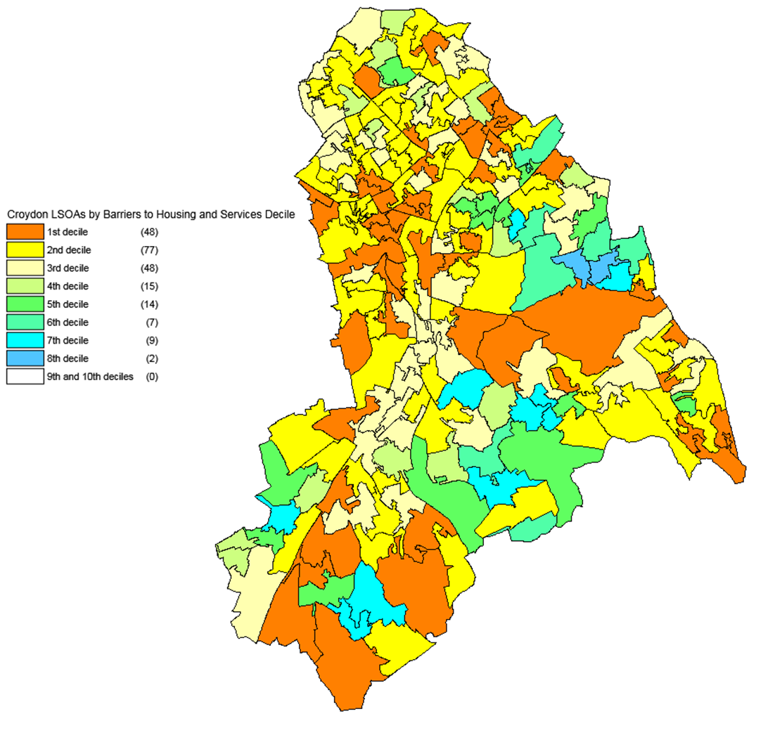

Source: DCLG and Ordnance Survey

**Living environment**

The living environment domain looks at both the indoor living environment and the outdoor living environment. The indoor living environment is based on the proportion of houses without central heating and the proportion of houses that are in poor condition. The outdoor living environment looks at air quality and road traffic accidents that cause injury to pedestrians and cyclists.

Croydon had an average score of 24.064 for the living environment domain, which means the authority was ranked 101st most deprived out of the 326 districts. Just 5% of the LSOAs in Croydon were in the top 10% most deprived areas nationally for this domain. As Figure 9 shows these are predominantly located in the centre of the borough. These areas have high scores both for the indoor and outdoor living environment measures.

Figure 9 – Living environment deciles

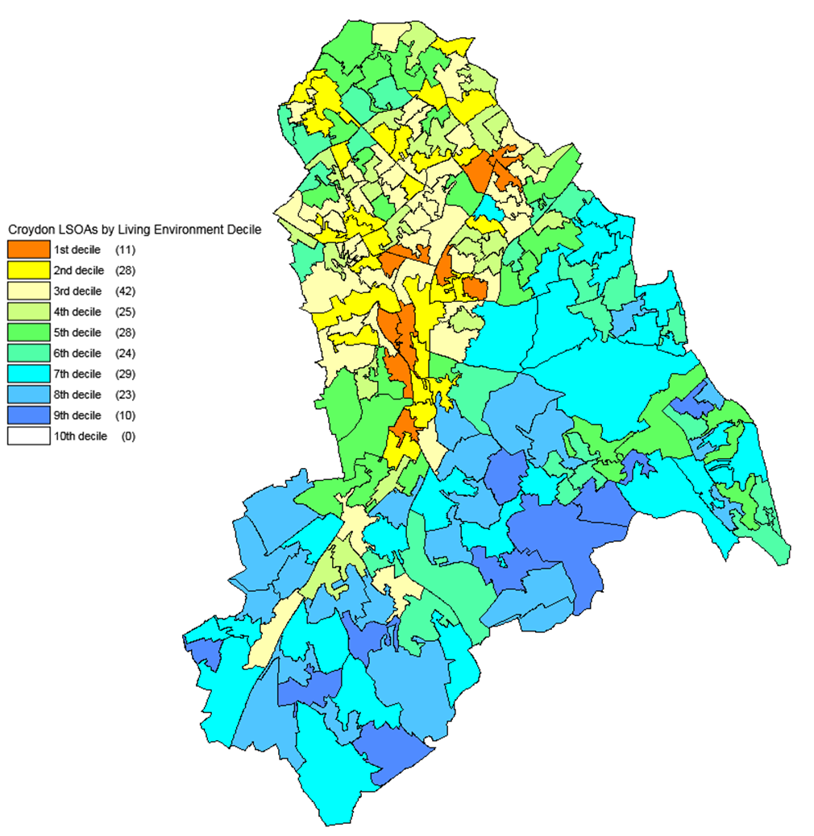

Source: DCLG and Ordnance Survey

**Income Deprivation Affecting Children Index (IDACI) 2015**

The Income Deprivation Affecting Children Index is a supplementary index that looks at the proportion of children in an area that are living in families affected by income deprivation.

At the time the Index was produced, Croydon had 23.2% of its children living in families affected by income deprivation. Croydon was ranked the 70th most deprived authority out of the 326 district authorities in England. 4% of the LSOAs in Croydon were in the top 10% most deprived LSOAs in the country, as can be seen in Figure 10.

These LSOAs are spread out across Croydon. However it is noticeable that overall the north and east of the borough are relatively more deprived than the south west of the borough. There is a southernmost area in the borough - the new Old Coulsdon ward, (formerly Coulsdon East) -which scores high on income deprivation affecting children.

Figure 10 – IDACI 2015 deciles

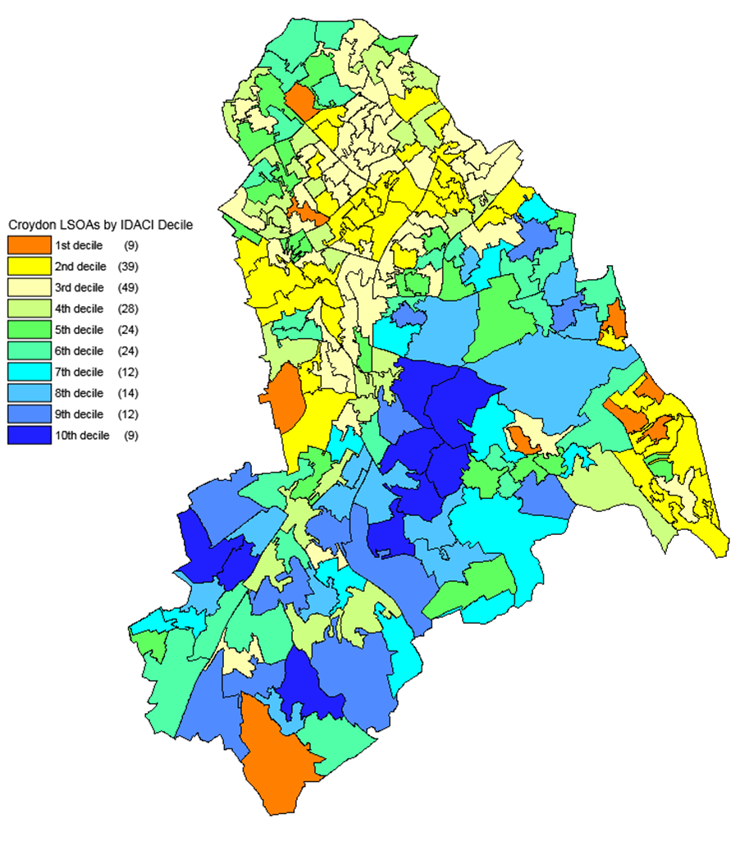

Source: DCLG and Ordnance Survey

**Income Deprivation Affecting Older People Index (IDAOPI) 2015**

The second supplementary index is the Income Deprivation Affecting Older People Index. This is the proportion of the population aged 60 and over who are income deprived.

In Croydon 17% of older people were income deprived. This was the 100th highest score out of the 326 district authorities in England, putting Croydon in the top third most deprived areas.

Figure 11 shows that nearly 8% of LSOAs in Croydon were in the top 10% most deprived areas in the country. These are predominantly in the north of the borough, with a few in the east.

There were more LSOAs in the top 10% most deprived areas in the country in the IDAOPI compared to the IDACI. The lower overall average score for Croydon for the IDAOPI is due to the higher proportion of LSOAs in the IDAOPI that are amongst the least deprived LSOAs in the country. This is offset by the large parts of the south of the borough which has LSOAs that are in the 30% least deprived areas of the country.

Figure 11 – IDAOPI deciles

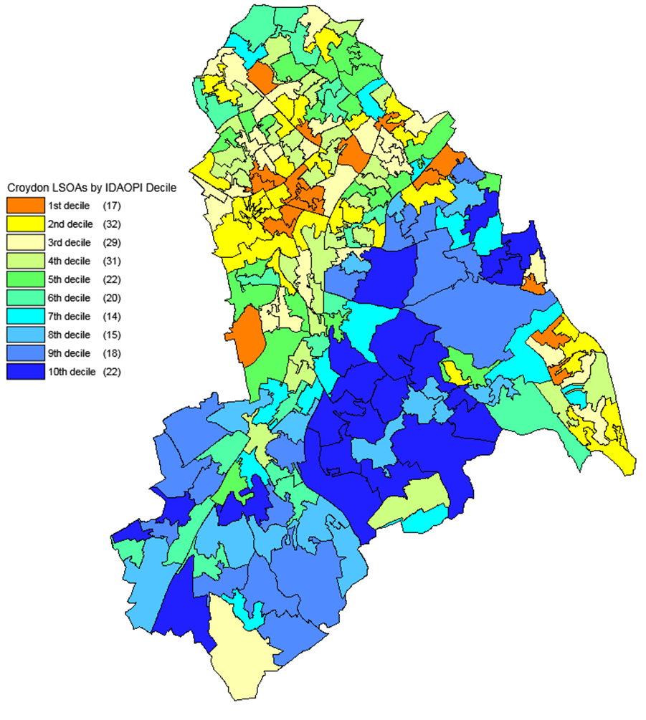

Source: DCLG and Ordnance Survey

** Education and skills**

Areas of progress

* Levels of persistent absence in schools remain very low each year.
* Attainment at the Early Years Foundation Stage is now in line with regional averages and above national averages.
* Attainment at Key Stage 2 has been improving but is still slightly less than the regional average.

Challenges

* Take up of funded hours in Early Years settings is still below regional and national averages.
* There remains a significant attainment gap for pupils from Black ethnic backgrounds.
* Few Croydon pupils achieve grades AAB or above at Key Stage 5 and latest results show that performance has worsened.
* The number of fixed term and permanent exclusions is decreasing.

**Overview**

Education and skills

* Early Years
* School attainment
* Further education

**Early Years**

**Take up of funded hours**

The percentage of 2 year old children benefitting from funded early education has been increasing, year on year. The percentage has increased from 38% in 2015 to 82% in 2018 and for Croydon this take-up rate is higher than outer London and national figures.

In Croydon, the take-up of some free education amongst 3 and 4 year olds is relatively high but it still remains below the London and England averages as Figure 1 shows.

Figure 1 – Percentage of 3 and 4 year olds taking up some free education

Source: DfE LAIT, data released October 2018.

**Foundation Stage**

The percentage of pupils achieving a good level of development in Croydon in the Early Years Foundation Stage has been steadily improving year on year. The latest results show that Croydon has performed in line with outer London and edged in front of the national average for 3 years running.

Figure 2 – Percentage of pupils achieving a good level of development

Source : DfE LAIT, data released October 2018.

**School attainment**

**Key Stage 1**

The proportion of pupils in Croydon achieving the expected standard in reading (77%) in 2018 remains in line with the regional average (78%) but higher than the national average of 75%. In Croydon, 72% of pupils achieved the expected standard in writing which was only just behind the outer London average (73%) and better than the national average (70%). The proportion of Croydon pupils who achieved the expected standard in Maths, (78% in 2018), was similar to the averages for Outer London (79%) and slightly higher than the average for England (76%).

**Key Stage 2**

In Croydon pupil attainment at this level has continued to improve over the last 3 years with performance better than the national average but slightly below the regional average as shown in Figure 3.

Figure 3 – Percentage of pupils reaching the expected standard in Reading, Writing and Mathematics at KS2

Source: DfE LAIT, data released October 2018.

**Key Stage 4**

Until 2016 attainment at Key Stage 4 was measured by counting 5 or more A*-C grades at GCSE including English and Maths (end of KS4).

From 2015 this measure was changed to Average Attainment 8 Score per Pupil. Attainment 8 measures the average achievement of pupils in up to 8 qualifications.

The Attainment 8 average score in Croydon has been decreasing since its introduction in 2015, moving from 49.9 in 2015 to 45.7 in 2018. Croydon performance over the last 3 years has been in line with the national average but has been consistently below the London average. In fact, 2018 shows Croydon attainment to be 4.1% lower than the outer London average.

In both years : 2016 and 2017, the proportion of pupils eligible for free school meals in Croydon achieving Attainment 8 has been lower than the London average but higher than the national average.

Figure 4 – KS4 Attainment 8 scores by FSM eligibility

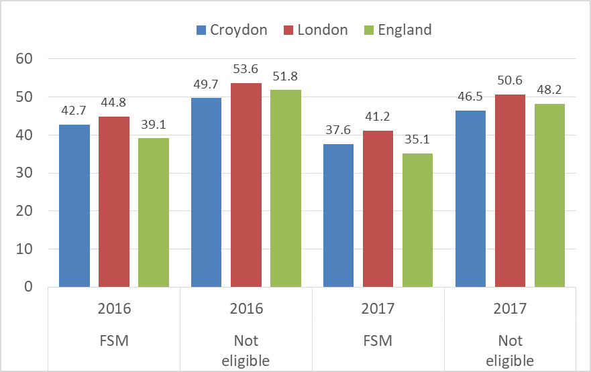

Source: DfE LAIT

Across the country there are variations in the proportions of pupils from different ethnic groups achieving Attainment 8 scores. Since 2015, at local, regional and national levels, there has been a lower proportion of pupils from Black backgrounds achieving Attainment 8 scores. Figure 7 shows the latest year’s figures and contrasts the other ethnic groups against pupils from a Chinese background who are attaining higher average scores for this measure.

Figure 5– KS4 Average Attainment 8 scores by ethnic group

Source: DfE LAIT.

**Attendance and exclusions**

The latest figures for 2017 show that the rates of authorised absences from primary schools (2.80%) and secondary schools (3.30%) in Croydon have been lower than the regional and national average rates.

Conversely, rates of unauthorised absences from Croydon primary and secondary schools have always tended to be higher than the regional and national figures. In 2017, unauthorised absence was 1.20% from Croydon primary schools and 1.9% from Croydon secondary schools.

Croydon has also seen a reduction in permanent exclusions. These are reported as the total number of exclusions as a percentage of the school population. The latest figure for Croydon for 2016/17 was 0.07% - lower than both the regional average of 0.08% and the national average of 0.10%.

Fixed period exclusions in Croydon had been below 3.00% in 2013 and 2014 but since 2015, there have been annual increases. The latest figure for 2017 is 3.70% compared to the regional average of 3.49% and the national average of 4.76%.

**Further education**

**Key Stage 5**

The proportion of pupils in Croydon achieving AAB grades at Key Stage 5 has consistently remained significantly below the regional and national averages, as shown in Figure 6.

Croydon schools have some way to go to catch up with the regional and national performance for this measure and Croydon’s worsening performance in 2018 at 8.4% should be a concern.

Figure 6 – The percentage of pupils achieving AAB grades

Source: DfE LAIT, data released October 2018.

**Level 2 qualification by age 19**

The latest figure for 2017 showed that 85.5% of young people in Croydon had achieved a Level 2 qualification by the age of 19. This is a poorer performance compared to the previous year (87.0%) but is still close to the national average of 85.6%.

Figure 7 shows that the proportion of young people in Croydon who had achieved a Level 2 qualification with English and Maths by age 19 has improved year on year but has dropped slightly to 68.8% which is slightly lower compared to last year’s 69.6%. Despite this being a drop, it is still better than Croydon’s statistical neighbours and in line with the national average.

Figure 7 – The percentage of 19 year olds with a level 2 qualification with English and Maths.

Source : DfE LAIT, data released October 2018.

The Department for Education measures the gap between the percentage of young people who were eligible for free school meals and those who were not eligible who attained a Level 2 qualification with English and Maths by age 19. The latest figure for 2017 shows that the gap has now dropped to 16.8% which is the lowest it has been for 9 years.

** Economy**

Areas of progress

* The number of businesses continues to grow.
* The proportion of out of work claimants has been going down every year for the last 5 years.

Challenges

* The job density in Croydon remains low.

**Overview**

This section provides a brief overview of the economy in Croydon looking at:

* Businesses
* Employment
* People out of work
* Apprenticeships
* Skill levels of adults

**Businesses**

As at March 2018, there were 14,675 enterprises comprising 16,615 local units in Croydon.[4] This number of enterprises is down by 1% on the previous year and signifies the first slight reduction during a 7 year period when annual increases have been the norm. There were only 35 of these enterprises (0.24%) that employed in excess of 250 people. The majority (84%) were enterprises employing only 0-4 people.

The 5 top industries for Croydon, based on the employment by the enterprise units are (i) Professional, scientific & technical, (ii) Construction, (iii) Information & communications, (iv) Retail and (v) Business administration & support services, as figure 1 shows.

Figure 1 – Enterprises by industry in Croydon, 2018Source: ONS UK Business Demography, Table 16

The number of business births in Croydon continues to grow year on year. In 2012 there were 1,765 new enterprises, in 2016 this increased to 2,905. Over the same period the number of business deaths fluctuated slightly more. In 2012 there were 1,580 business deaths, rising to 2,065 in 2016.

The overall number of active enterprises increased every year from 13,020 in 2012 to 16,855 in 2016.

The proportion of businesses that were started in 2015 that were still active in 2016 was 92.4% in Croydon. This compares with the 86.4% London average for businesses that survived their first year from 2015.

Table 1 shows that the survival rates of businesses born in 2012 were higher in Croydon than in London with Croydon rates being more similar to the averages for England up to the 3 year survival period.

Table 1 – Survival rates of enterprises born in 2012

|  |  |  |  |  |
| --- | --- | --- | --- | --- |
|  | 1 Year Survival Rate | 2 Year Survival Rate | 3 Year Survival Rate | 4 Year Survival Rate |
| Croydon | 93.20% | 73.70% | 58.40% | 46.74% |
| London | 89.70% | 70.80% | 55.40% | 46.46% |
| England | 91.10% | 73.70% | 59.20% | 50.21% |

Source: ONS Business Demography, released Nov.2017.

The ONS business counts now include more PAYE businesses than in previous years which means that the data for 2015 is not comparable with the historic figures. In 2015 there were approximately 12,880 enterprises in Croydon, almost all of these were small to medium enterprises.

**Employment**

Nearly 3 in 4 (73.7%) of Croydon residents aged 16-64 years are in employment. This is slightly lower than in London and at the national level. The regional and national employment rates have increased slightly on the previous year.

However, Croydon has seen a reduction in the proportion of those employed by almost 5% since the previous year when the employment rate was 78.5%.

Table 2 – Employment and unemployment in Croydon –

July 2017-June 2018)

|  |  |  |  |  |
| --- | --- | --- | --- | --- |
|  | **Croydon** | **Croydon** | **London** | **Great Britain** |
| **(nos)** | **(%)** | **(%)** | **(%)** |
| Economically active† | 207,200 | 79.5 | 78.3 | 78.4 |
| In employment† | 192,700 | 73.7 | 74.2 | 75 |
| Employees† | 162,000 | 62.8 | 60.6 | 64.2 |
| Self employed† | 29,500 | 10.5 | 13.3 | 10.6 |
| Unemployed (model-based)§ | 13,700 | 6.6 | 5.1 | 4.2 |

Source: ONS, Annual Population Survey

† - numbers are for those aged 16 and over, % are for those aged 16-64

§ - numbers and % are for those aged 16 and over. % is a proportion of

economically active

The latest job density figure for Croydon is 0.59 (2016). The density figure represents the ratio of total jobs to population aged 16-64. In Croydon, this has been increasing in the past

few years but is still much lower than in London (0.99) and Great Britain (0.84).

The difference in average gross earnings for male full-time workers is only about £45 a week between those who work in Croydon and those who live in Croydon. However, for females the difference is about £12 a week.

Figure 2 – Gross weekly earnings for workers in Croydon, 2018

Source: ONS ASHE, resident analysis

Figure 3 – Gross weekly earnings for Croydon residents, 2018

Source: ONS ASHE, workplace analysis

The higher earnings for those living in Croydon is likely to be linked to the high proportion of residents who commute into central London. The 2011 Census figures suggest that Croydon is a net exporter of workers.

The number of jobs in Croydon each year, over the past 3 years to 2017 has averaged at around 119,000 per year. Latest estimates for 2017 suggest that Croydon has a much higher than average proportion of jobs in the wholesale and retail sectors, in health and social work and in education.

Professional and administrative support services also feature at around 8% in Croydon.

Figure 4 – Top 6 Employee jobs 2017

Source: ONS business register and employment survey

Nearly a half (48.5%) of the jobs in Croydon comprise occupations such as managers, directors, senior officials, professional, associate professional & technical staff. This is not surprising as the Council offices and other public sector offices are located in Croydon as well as law firms.

Occupations in the services sector including care, leisure, sales and customer services account for 19.3% of the total occupations in Croydon. This is higher than the London and national averages.

Figure 5 – Employment by Occupation for those aged 16+ years, (July 2017-June 2018)

|  |
| --- |
| Source: ONS annual population survey |

**People out of work**

The number of people claiming job seeker’s allowance (JSA) was used to measure the number of people out of work.

Since the introduction of Universal Credit, the JSA counts have not proved to be very reliable. As a result, the

Claimants of out of work benefits have been adopted as a more meaningful measure. This records the number of people claiming benefit principally for the reason of being unemployed. It combines the number of people claiming Jobseeker's Allowance (JSA) and National Insurance credits with the number of people receiving Universal Credit as a result of being unemployed.

The number of people claiming out of work benefits has fallen steadily since the end of the recession. Figure 6 shows that the rate of decrease has been in line with the regional and national averages but the latest figure for November 2016, shows that there has been a drop in the number of claimants in Croydon. This may be the result of the Council Gateway services helping people to work.

Figure 6 – Proportion of out of work claimants

*Source: ONS claimant count*

**Apprenticeships**

The number of apprenticeship framework achievements have been increasing in Croydon for years. The 2016/2017 figures for programme starts by local authority is the latest data available.

With 2,330 new apprenticeship starts during 2016/2017, Croydon has the second highest proportion of new apprentices in that year at 5.5% behind only Newham (5.7%). This compares to the London average of 3.0%.

Figure 7- New apprenticeship starts during 2016/2017 broken down by London councils

*Source : gov.uk*

**Skill levels of adults**

**No qualifications**

Based on the 2011 Census, 17.6% of adults in Croydon were recorded as having no qualifications and this was in line with the London average. Across England this figure was higher at 22.5%.

Based on the ONS annual population survey for the calendar year 2017, only 4.7% of Croydon’s resident population aged 16-64 years had no qualification. This proportion was higher in London (6.8%) and also higher at the national level (7.7%).

Figure 8 shows that adults from a White ethnic background in Croydon are more likely to have no qualifications than adults from any other ethnic background. This is likely to be because just over a third of adults in Fieldway and New Addington had no qualifications recorded in the 2011 Census and both of these areas have a higher proportion of residents from White ethnic backgrounds.

Figure 8 – Highest level of qualification by ethnic group

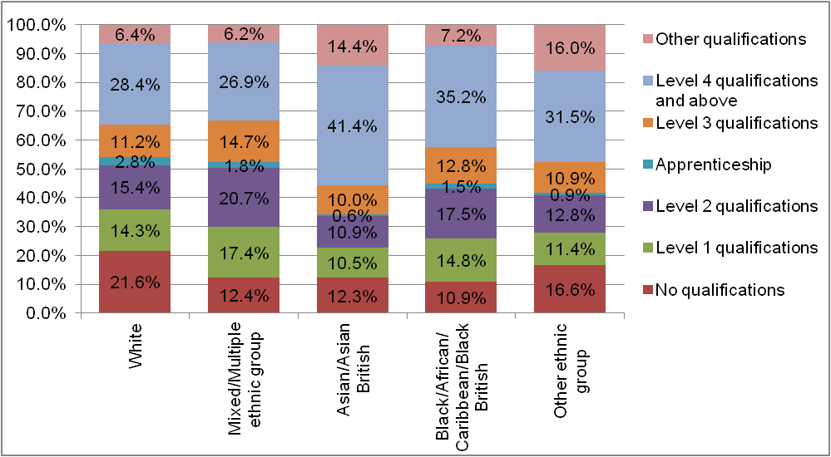

Source: ONS 2011 Census Table DC5209EWla

Figure 9 shows the differences in the skill levels across the borough based on Census 2011 data. Whilst Fieldway and New Addington had the highest proportion of adults with no qualifications, Croham and Fairfield had the lowest at 12.0% and 12.3% respectively.

Figure 9 – Highest qualification by ward

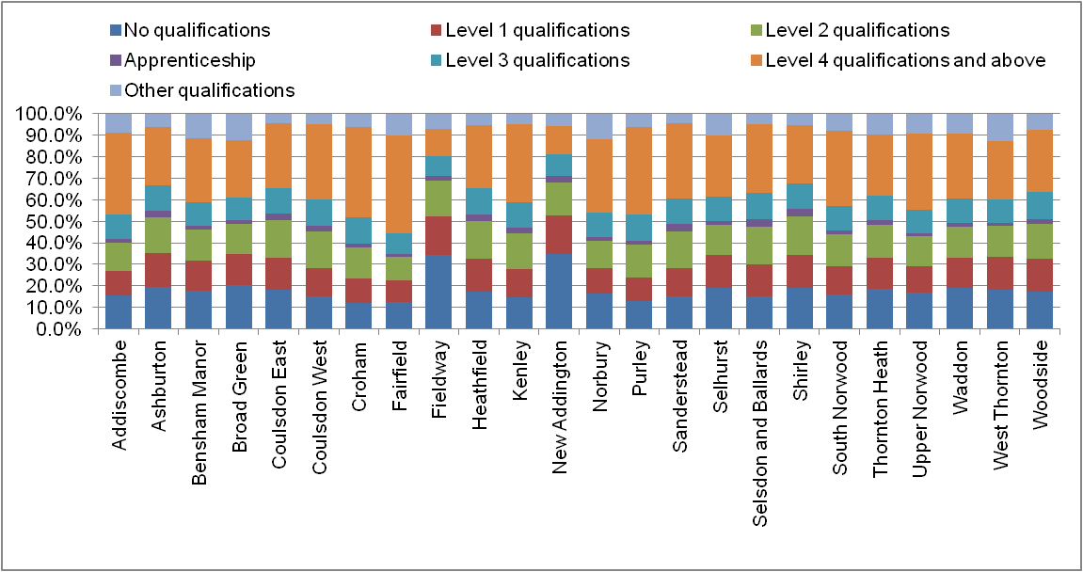

Source: ONS 2011 Census Table QS501EW

Please note that since May 2018, Croydon has become a 28 ward borough and, as well as 4 new wards, some of the former ward names have been changed

.

** Housing**

Areas of progress

* Croydon remains one of the most affordable areas to live in London both to buy and to rent.
* Croydon had the second highest number of net additional dwellings in 2016/2017.

Challenges

* The number of homeless acceptances remains high.
* The number of homeless households in temporary accommodation remains high.

**Overview**

This section looks at some of the main issues relating to housing in Croydon including:

* Tenure
* Cost of property
* Availability of housing
* Homelessness

**Tenure**

According to the 2011 Census, 60.1% of all Croydon households were owner occupied, 22.1% were private rented or rent free households and 17.8% were households living in social housing.

The GLA’s report on Housing Characteristics[5], highlighted that 72.0% of houses in London were owner occupied of which owner occupied flats were 28.5%. Social rented housing in London was lower than Croydon and only accounted for 12.8% of all houses. Likewise, private rented homes in London made up a smaller proportion of the total housing stock at 15.2% compared to Croydon’s 22.1%.

In the Census 2011, over half (50.8%) of households had a head of household who was aged between 25 and 49 years of age with 35.3% aged 50 to 74 years. There were only 3.6% of the households occupied by people aged 24 years or younger and at the other end, 1 in 10 (10.3%) that were headed by a person aged above 75 years.

Figure 1 - Tenure type by age bands in Croydon in 2011

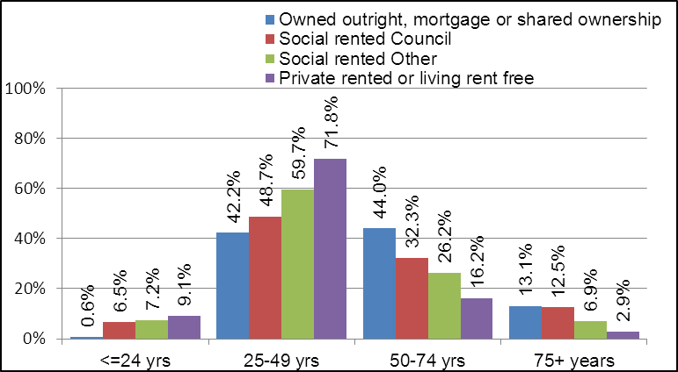

Source: ONS, Census 2011, Table DC4201EW.

Croydon has the largest borough housing stock in London but its social housing stock is smaller than many other London boroughs. Social housing in Croydon is mainly concentrated

In the north and the eastern edge of the borough. The 2011 Census showed that the eastern wards of Fieldway and New Addington had the highest proportions of social housing (council homes and other) with 60.6% and 42.2% respectively. Selsdon and Ballards had the lowest percentage of social housing at only 2.0%.

Figure 2 – Percentage in rented accommodation by ward in Croydon in 2011

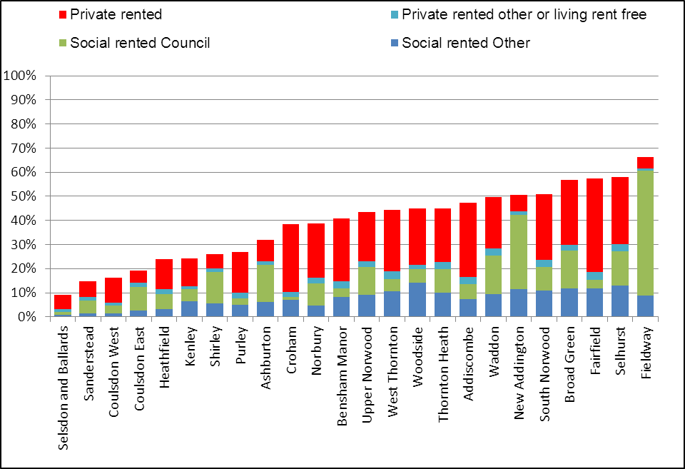

Source: ONS, Census 2011, Table DC4201EW.

**Cost of property**

The number of house sales in Croydon increased by 25% from 2013 to 2014, prior to Brexit. Since then, the volume of property sales has decreased to around the high 5,000 level. In 2016, the number of sales dropped to around 5,300 possibly due to the uncertainty of the property market following the Brexit outcome. These figures do not include “right to buy” sales, or properties sold for less than £1,000 or more than £20 million.

Figure 3 – House sales in Croydon 2013-2017

Source: GLA Housing Sales dataset based on Land Registry data.

The median cost of properties in Croydon has risen by 52% from £240,000 in 2013 to £365,000 in 2017. However, these figures are strongly influenced by the housing mix. In Croydon there is a high proportion of sales of flats and apartments which are quite over-priced and this raises the median cost of properties in the borough.

The last 5 years has seen an increase in the average price of properties in the borough. Every property type has increased in value, year on year, from detached houses to one bedroom flats, as shown in Figure 4.

Figure 4 – Change in property prices

Source: GLA Average House Prices dataset based on Land Registry data.

Despite the rising property prices, Croydon has the fourth lowest ratio of average earnings (for full-time workers) to average house prices across London so remains one of the more affordable boroughs to live in.

Figure 5: Ratio of house prices to earnings

Source: GLA Ratio of House Prices to Earnings (full-time workers by place of work), 2017

Nationally, around 78% of households, where the main reference person is aged over 65 years, own their own homes. Figure 6 shows that there has been a decrease over the last five years’ worth of data for those aged 35-44 years who own their own properties. For the 16-24 and 25-34 year age groups, the proportion based on 5 year averages is around 9% and 38% respectively.

Figure 6: Percentage of each age group that are owner occupiers

Source: DCLG, Owner occupiers, recent first time buyers and second homes, Table FC2101, 2017.

Using median monthly private rental data from the VOA and median gross monthly salary for 2017 from the ONS, it is possible to calculate the private rent over the gross monthly salary. Figure 7 shows that although the median monthly private rent is 39% of the median gross monthly salary in Croydon, this is still far lower than for most of the other London boroughs.

Figure 7: Median monthly private rent as a percentage of the median gross monthly salary 2017

Source: Valuation Office Agency and ONS, ASHE.

**Availability of housing**

The number of long-term vacant dwellings in Croydon in October 2016 was 1,216[6]. Compared to the 33 London borough, Croydon had the 2nd highest number of long-term vacant dwellings in 2016 behind Kensington & Chelsea. However, this actually only represents less than 0.8% of the total number of dwellings in the borough. Looking at the approximate proportion of empty dwellings in each London borough, Croydon has the 5th highest rate.

Croydon’s local housing market assessment[7] (LHMA) has estimated that 22% of all households in Croydon are unsuitably housed, mostly in the north of the borough. For 2010 to 2031, the LHMA is estimating that Croydon will require an extra 27,000 homes made up of 18,000 from Market housing, 1,700 from intermediate housing and 7,300 from affordable housing.

Croydon had the second highest number of net additional dwellings, (2,835) in 2016/2017 out of all the London boroughs, behind only Tower Hamlets (4,827). There have been an additional 2,128 dwellings created in Croydon since 2011/2012. These have included new builds, conversions and changes of use.[8] This raised the total number of dwellings in the borough to 154,560. Croydon continues to have the largest number of dwellings of any of the London boroughs.

**Homelessness**

Due to limited, social housing in Croydon is only allocated to people with the most urgent housing need. The Council has applied the Localism Act 2011 to fulfil its legal duties to homeless households by providing accommodation with private landlords in order to provide much needed accommodation for a constant housing demand.

The most common reason for homelessness is parental evictions, by exclusions by relatives and friends and relationship breakdowns. Croydon was the first London borough to achieve the government target of halving its use of temporary accommodation.

Over the years, by far the highest proportion of accepted homeless households in Croydon have been made up of lone parents with dependent children.[9]

There were 2,005 households in temporary accommodation as at the end of March 2018. This reduction signifies the lowest number since 2012/2013.

Figure 8: Croydon Households in temporary accommodation

Source : Homelessness Review and Strategy, 2018, Sect. 5.44

In every age band, there is a disproportionately high percentage of homeless people from the Black community. Latest trends show that, of the households accepted as homeless in Croydon, around half are made up of people from the Black community, around a quarter are from the White community with the remainder made up of residents from all the other communities.

Figure 9 – Percentage of Homeless households accepted in Croydon by Broad Ethnic Group

Source : Homelessness Review and Strategy, 2018, Sect. 6.5

Past trends show that around 1 in 5 residents who are accepted as homeless are in the 16-24 years age band. The latest figures show that the majority of homeless people (58%) in Croydon are concentrated in the 25-44 years age group. One in 5 (22%) are aged between 16 and 24 years and again one in 5 (20%) are aged 45-59 years. There are very small proportions of people aged 60 years and over.

Figure 10 - Number of homeless households accepted in Croydon by set age bands

Source : Homelessness Review and Strategy, 2018, Sect. 6.3

** Health**

Areas of progress

* Breastfeeding prevalence at 6-8 weeks remains higher than the national average.
* The percentage of adults smoking in Croydon continues to fall and is below the national average.
* Life expectancy at birth for men and women continues to increase.
* The teenage conception rate in Croydon is still one of the highest in London but the trend has continued downwards since 1998.

Challenges

* Vaccination coverage remains low for a number of child and adult vaccinations.
* The proportion of patients with a diabetes diagnosis remains high.
* The rate of injuries due to falls in over 65s also remains high.

**Overview**

This section looks at the general health of the population in the borough, focusing on issues relating to Public Health.

* General health
* Children and young people’s health
* Adults’ health and lifestyle
* Disease and poor health
* Life expectancy and cause of death

**General health**

The 2011 Census asked residents to rate their general health as very good, good, fair, bad or very bad. In Croydon 83.4% of residents had very good or good health and only 4.6% had bad or very bad health.

This was better than the national average, across England where 81.4% of people had very good or good health and 6.7% had bad or very bad health. The London figures were also above the national average with 83.8% of Londoners recording that they had very good or good health and only 5.0% recording bad or very bad health.

82.2% of females in Croydon said they had very good or good health, lower than the 84.8% of males. A higher proportion of females had bad or very bad health at 4.9%, compared to only 4.3% of males.

The younger population in Croydon indicated very good or good health as shown in Figure 1. Only half of the population aged 65 and over said they had very good or good health.

Figure 1 – General health by age group

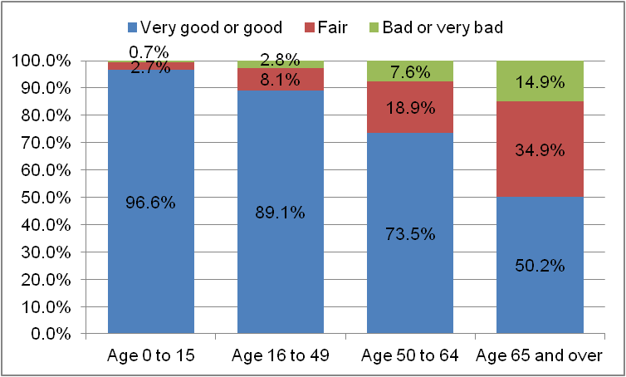

Source: ONS Census 2011 Table LC3206EW

The highest proportion of Croydon residents who reported very good or good health were from mixed or multiple ethnic backgrounds. Figure 2 shows that a higher proportion of residents from white ethnic backgrounds reported fair or bad or very bad health.

Figure 2 – General health by ethnic group

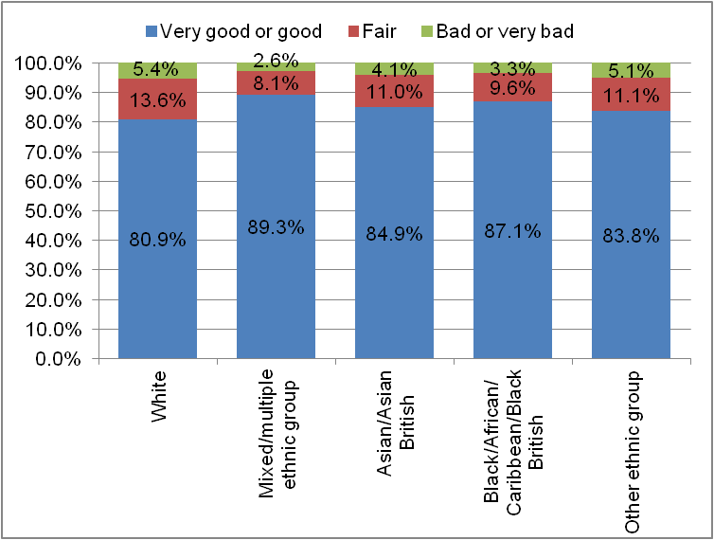

Source: ONS Census 2011 Table LC3206EW

Croydon residents whose day to day activities were limited by a long-term illness or disability reported poorer general health than those whose activities were not limited.

The proportion of people whose day to day activities were limited a lot who reported bad or very bad health was slightly lower than the national average at 51.9% compared to 53.2% across England.

Figure 3 – General health by long term limiting illness or disability

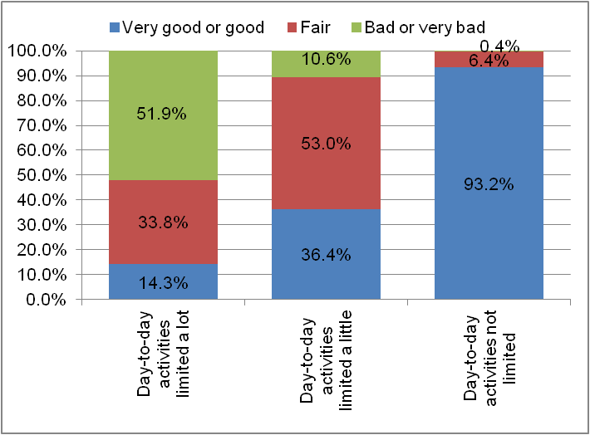

Source: ONS Census 2011 Table LC3302EW

In Croydon, 36.4% of people whose day to day activities were limited a little reported very good or good health which was similar to the national figure of 36.2%. The proportion who reported bad or very bad health was slightly higher at 10.6% compared to the national average of 9.2%.

**Children and young people’s health**

**Low birth weight**

Low birth rate is classified as any weight less than 2,500 grams. The Public Health Profile for 2016 shows that the percentage in Croydon was 2.96% which was similar to the national average of 2.79%. Across London the figure for 2016 was also 3.01%.

**Breastfeeding**

Figure 4 shows that for a number of years, the proportion of mothers who breastfeed their children at 6-8 weeks from birth in Croydon has been far higher than the England average[10]

This measure has ceased to be reported at local authority level from 2016/2017 as there have been issues concerning the quality of local data and data across London. It is now reported to the Primary Care Trust (PCT) and mapped across to the local authority where possible.

Figure 4 - Breastfeeding prevalence at 6-8 weeks

Source: PHE Public Health Outcomes Framework Tool

**Immunisations**

In 2017/2018, childhood immunisation rates in Croydon remained statistically lower than both the London average and the England average for all immunisations. For the year, Croydon failed to meet a single child immunisation national target set at 90% coverage.[11]

Table 1 – Coverage of childhood immunisations,2017/2018

|  |  |  |  |
| --- | --- | --- | --- |
|  | Croydon | London | England |
| Dtap/IPV/Hib (1 year old) | 86.7% | 89.2% | 93.1% |
| Dtap/IPV/Hib (2 years old) | 88.8% | 91.7% | 95.1% |
| PCV | 87.4% | 89.7% | 93.3% |
| Hib/MenC booster (2 years old) | 80.8% | 85.1% | 91.2% |
| Hib/MenC booster (5 years old) | 81.2% | 88.1% | 92.4% |
| PCV booster | 81.2% | 84.3% | 91.0% |
| MMR one dose (2 years old) | 80.3% | 85.1% | 91.2% |
| MMR one dose (5 years old) | 85.6% | 91.4% | 94.9% |
| MMR two doses (5 years old) | 73.1% | 77.8% | 87.2% |

Source: PHE Public Health Outcomes Framework Tool

Coverage of the HPV vaccine in Croydon has been significantly lower than the national average for the last 3 years. The coverage of the vaccine in Croydon for 2016/2017 was 77.8% of girls aged 12-13, compared to 83.8% across London and 87.2% across England.[12]

**Excess weight**

Excess weight in primary school pupils remains a concern in Croydon. The proportion of Croydon pupils in Year 6 measured as having excess weight was 37.7% (2016/2017) and remains higher than the England average (34.2%) but the London average at 38.5% is higher than the Croydon rate.[13]

Figure 5 – Excess weight in pupils in Year 6

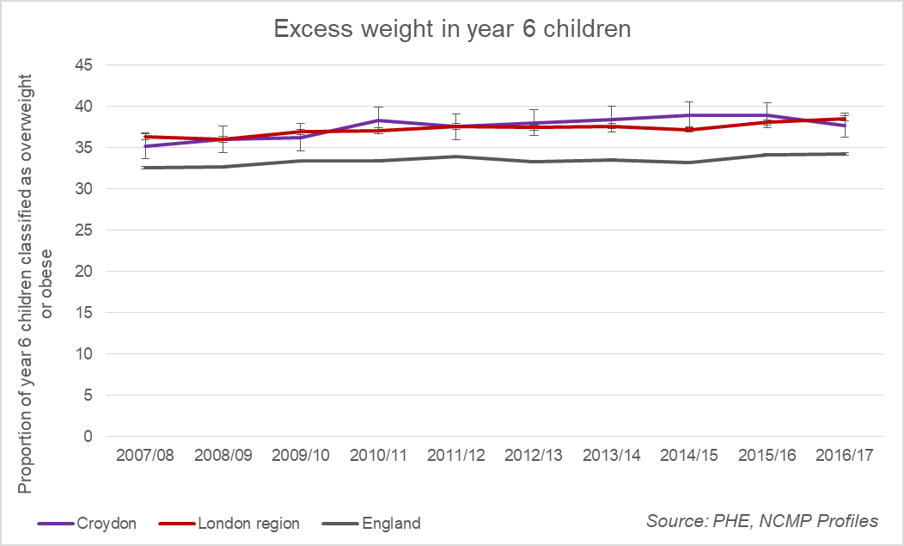

Source: NCMP

The proportion of Croydon pupils in Reception year (aged 4-5) measured as having excess weight increased to 23.7% in the latest year (2016/2017).[14] This is higher than both the rate in London of 22.3% and the national rate of 22.6%.

Figure 6 – Excess weight in pupils in Reception

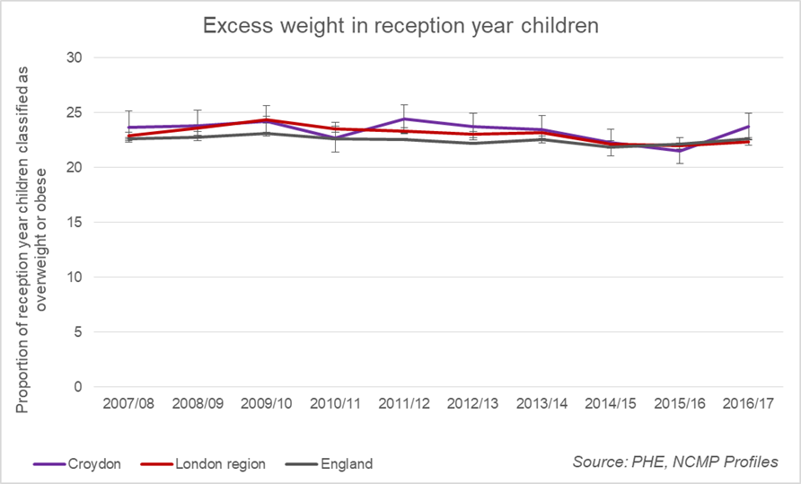

Source: NCMP

**Teenage conceptions**

Croydon had the third highest teenage conception rate (for girls aged under 18) in London in 2016, (behind Barking & Dagenham and Southwark), according to the latest ONS statistics.[15] Overall there has been a downward trend in teenage conceptions since 1998.

Figure 7 - Under 18 conception rate

Source: ONS Conception statistics

The maternity rate for under 18s in Croydon was 6.0 per 1,000 girls aged 15-17 in 2016, a decrease from the rates of 8.5 in 2015 and 10.4 in 2014.[16] The rate of abortions increased slightly from 15 abortions per 1,000 girls aged 15-17 in 2015 to 16 in 2016.[17]

For 2014-2016, Croydon had the second highest rate of under 16 conceptions in London, behind Lambeth. There were 5.5 conceptions per 1,000 girls aged 13-15 in Croydon, compared to 3.2 per 1,000 girls across London and 3.7 per 1,000 across the country.[18] The percentage of under 16 conceptions that resulted in abortion in 2014-16 was 68.2% in Croydon. This was lower than the percentage across London (69.3%) but higher than the abortion rate in England (61.6%).[19]

**Sexually transmitted infections**

Over the last 5 years, Croydon has had a better Chlamydia detection rate than the regional and national averages. In 2017 the rate in Croydon was 2,519 per 100,000 young people aged 15-24, higher than London (2,199 per 100,000) and England (1,881 per 100,000).

In 2017, 21.2% of those aged 15-24 were screened for Chlamydia in Croydon, higher than the 19.3% screened nationally and lower than the 24.0% screened across London.[20]

In 2017, the rate for all new STI diagnoses (excluding Chlamydia diagnoses in those aged <25 years) remained much higher in Croydon compared to the England average. In Croydon there were 1,283 diagnoses per 100,000 population compared to 794 per 100,000 across England and 1,547 per 100,000 in London.[21]

**Adults’ health and lifestyle**

**Excess weight**

The proportion of adults aged 18 years and over with excess weight in Croydon was approximately 59.0% for the period

2016/2017. This is a reduction on the previous year’s figure of 65.4%. The average across London in 2016/2017 was only 55.2% and the national average figure was higher at 61.3%.[22]

Figure 8 – Proportion of adults with excess weight 2016/2017

Source: PHE Health Profiles

**Physical activity**

The Active Lives survey from 2016/2017 suggests that 64.2% of adults aged 19 and over in Croydon achieved 150 minutes of moderate intensity exercise per week in line with the national guidelines. This is similar to both the national figure of 64.9% and the regional average of 64.6%.

**Smoking prevalence**

The proportion of adults aged 18 and over in Croydon who were self-reported smokers, in the 2017 Annual Population Survey, was approximately 12.0%. This was lower than both the regional average of 14.6% and the national average of 14.9%. For Croydon it was also a slight decrease on the previous year when the proportion was 13.2%.

**Flu vaccinations**

Croydon has seen a relatively low coverage of flu vaccinations over the last seven years Croydon - below the national average for those aged over 65 years.

In 2017/2018, 65.9% of those aged over 65 received a flu jab compared to 66.9% in London and 72.6% nationally. Around

42.3% of “at risk” individuals aged 6 months to 64 years received the flu vaccination compared to 45.4% in London and 48.9% in England.[23]

**Wellbeing**

The ONS Annual Population Survey asks questions relating to personal wellbeing. Participants are asked to score how satisfied they feel with their life overall; to what extent they feel the things they do in their life are worthwhile; how happy they felt yesterday; and how anxious they felt yesterday. There is a degree of uncertainty in the estimates produced for local authorities due to the sample sizes involved. However, the latest data (2016/2017) suggests that Croydon residents have similar personal wellbeing ratings than the regional and national averages.[24] similar personal wellbeing ratings than the regional and national averages.[25]

**Disease and poor health**

**Mental health**

Approximately 1.11% of patients registered in Croydon in 2016/2017 had been diagnosed with a severe mental health condition. This was s higher than the national average of 0.92% but in line with the average for London of 1.10%.

**Dementia**

The government’s challenge for dementia included a commitment to increase the number of people living with dementia who have a formal diagnosis. The rationale being that a timely diagnosis enables people living with dementia, their carers and healthcare staff to plan accordingly and work together to improve health and care outcomes.

The rate of persons aged 65 and over with a recorded diagnosis of dementia per person estimated to have dementia given the characteristics of the population and the age and

sex specific prevalence rates of the Cognitive Function and Ageing Study II, expressed as a percentage with 95% confidence intervals.

Over the first 2 years of estimation, the rate of diagnosis in Croydon has been slightly below the averages for London and England and in line with the target of 66.7.

Figure 9 – Dementia diagnosis rate (65+ years)

*Source: NHS Digital*

**Diabetes**

The estimated diabetes diagnosis rate is expressed as a percentage of the observed number of people with a formal diagnosis of diabetes over a proportion of the estimated number with diabetes.

The prevalence of diagnosed diabetes in patients aged 17+ registered in Croydon has been slightly lower than the regional and national averages for the past 3 years but the trend is showing a slight rise in this rate.

Figure 10 – Diabetes prevalence in 17+ year olds

Source: PHE Health Profiles

**Tuberculosis**

Croydon has a lower rate of new reported cases of TB than the London average. In 2015-2017, there were an estimated 21.3 new cases of TB per 100,000 population compared to a rate of 24.3 cases across London and 9.9 cases nationally.[26]

Figure 11 – Incidence of new cases of TB per 100,000 population

Source: PHE Health Profiles, *Enhanced Tuberculosis Surveillance system (ETS*)

**Falls in over 65s**

The rate of hospital admissions due to falls in people aged 65 and over in Croydon remains consistently higher than the national and regional averages. There was a slight rise in the rate in 2016/2017 in Croydon to 2,710 emergency hospital admissions for injuries due to falls per 100,000 people.[27]

Figure 12- Injuries due to falls in over 65s per 100,000

Source: PHE Health Profiles, Hospital Episode Statistics (HES)

**Drug treatment**

The successful completion of drug treatment for opiate users is measured by the number of users of opiates that left drug treatment successfully (free of drug(s) of dependence) who do not then re-present to treatment again within 6 months as a percentage of the total number of opiate users in treatment.

Croydon’s success rate has improved over the last year and is in line with the London and better than the national average.

Figure 13 - Successful completion of drug treatment - opiate users

Source: Calculated by PHE: Knowledge and Intelligence Team (North West) using data from the National Drug Treatment Monitoring System

**Alcohol treatment**

The successful completion of alcohol treatment is measured by the number of alcohol users that left structured treatment successfully (free of  alcohol dependence) who do not then re-present to treatment within 6 months as a percentage of the total number of alcohol users in structured treatment.

For the past 7 years, Croydon has consistently been less successful with alcohol treatment compared to London and England generally.

Figure 14 - Successful completion of alcohol treatment

Source: Calculated by PHE: Knowledge and Intelligence Team (North West) using data from the National Drug Treatment Monitoring System

**Substance Misuse**

1,130 adults were in treatment (tier 3 and tier 4) for substance misuse issues in Croydon in 2013/14. This represents a slight increase on earlier years. 73.1% of adults in treatment were from a White ethnic background, far higher than the proportion of adults from this group in the general population.

Just over a third of clients were in treatment for opiate and crack usage, with just under a quarter in treatment for opiate usage only.[28]

**Life expectancy and cause of death**

**Life expectancy at birth**

Life expectancy at birth for men in Croydon was on average approximately 80.3 years for the period 2014-16. This is in line with the regional average (80.4) and higher than the national average (79.5). The life expectancy for women was slightly higher at 83.6 years, this is below the London average of 84.2 years, but similar to the England average of 83.1.[29]

**Mortality rates**

During 2015-2017 there were 3.6 deaths of infants aged under 1 year per 1,000 live births. This was in-between the regional (3.3) and national (3.9) rates.[30] The rate of deaths in Croydon from causes that were considered preventable has been either in line with, or lower than the regional and national average for the last 15 years.

Figure 15 – Mortality rate from causes considered preventable (standardised rate per 1,000 persons)

Source: PHE Public Health Outcomes Framework Tool

The mortality rate for cardiovascular disease for those aged under 75 in Croydon remains in line with the national average. For the period 2014-16 there were approximately 77.2 deaths

was 126.8.

**Smoking related deaths**

The rate of smoking related deaths in Croydon remains better than the national average. For the period 2014-16 there were approximately 234.5 deaths per 100,000 people in Croydon compared to 246.7 across London and 272.0 nationally.[31]

**Suicide rate**

The suicide rate in Croydon was lower than both the regional and national averages at 7.1 deaths per 100,000 for 2015-2017. For this period the London rate was 8.6 and the national rate was 9.6.[32]

**Excess Winter deaths**

Excess winter deaths are reported as the ratio of extra deaths that occur during the winter months compared to the number of expected deaths based on the average number of non-winter deaths.

The latest calculated figure for the period August 2016 to July 2017 for Croydon was 19.8 which was lower than both London (22.9) and England (21.6).

Figure 16 - Excess winter deaths index (single year, all ages) calculated from August to the following July.

Source: Office for National Statistics: Public Health England Annual Births and Mortality Extracts

 **Social care**

Areas of progress

* A reduction in the rate of children in need.
* A reduction in the number of local Looked After Children
* Improvement in the effectiveness of reablement services in Croydon since 2010/11.The latest outcome for 2017/2018 shows Croydon is doing much better than the average for both London and England.

Challenges

* The rate of referrals to children’s social care is now higher than both the regional and national averages.
* The demand for local authority children’s services remains high in line with national trends.
* Croydon has the highest number of Looked After Children in London.

**Overview**

This section provides a brief overview of social care clients in Croydon. It looks at:

* Children in need
* Looked After Children
* Adult safeguarding
* Adults receiving care

**Children in need**

As at 31 March 2017, there were 392.7 children in need for every 10,000 children in Croydon. A year later and the rate of children in need in Croydon has risen to 548.50 per 10,000 which is close to the all-time high of 569.3 per 10,000 children in 2011.

The most common reason for a child being in need in Croydon is abuse or neglect and absent parenting. The high figures are distorted by the high number of unaccompanied asylum seeking children in the borough.

The rate of referrals to children’s social care increased to 548.50 per 10,000 in 2017/2018 and is now noticeably much higher than both the regional and national averages.

Figure 1 – Rate of referrals per 10,000 children

Source: DfE LAIT

The number of section 47 enquiries, investigations undertaken where there is reasonable cause to suspect that a child is suffering or is likely to suffer significant harm, has been rising in Croydon since 2013/2014.

Figure 2 shows that the rate of section 47 referrals in Croydon has not only been increasing since 2013/2014 but has increased above the London and England rates for the first time. The latest Croydon rate for 2017/2018 is 169.3 per 10,000 children.

Figure 2 – Rate of section 47 enquiries per 10,000 children

Source: DfE LAIT

The rate of initial child protection conferences for 2017/2018 in Croydon has gone up significantly on previous years reaching 90.1 per 10,000 children. This rate compares with a rate of 59.6 in outer London and a national rate of 67.0 per 10,000 children.

Figure 3 – Rate of initial child protection conferences per 10,000 children

Source: DfE LAIT

The rate of children subject to Child Protection Conferences (CPP) in Croydon has been increasing steadily in recent years. However, the latest year of 2017/2018 has seen a marked rise in this rate, moving from 37.0 in the previous year to 59.6 per 10,000 in 2017/2018.

Figure 4 – Rate of children subject to a child protection plan as at 31 March

Source: DfE LAIT

Nearly one in 7 (14.4%) of people who were subject to a child protection plan as at 31 March 2017 had an initial category of abuse of neglect as can be seen from Figure 5. Multiple abuse which included Physical and Sexual abuse accounted for 41.3% of all abuse categories in Croydon. Just over a quarter (25.9%) of all the abuse recorded was Emotional abuse.

Figure 5 – Initial category of abuse for children subject to a child protection plan as at 31 March 2017

Source: SFR61/2017, Table D2.

**Looked After Children**

Croydon has the highest number of looked after children of any London borough as shown by Figure 6. This is due to the high numbers of unaccompanied asylum seeking children (UASC) looked after by the borough.

Figure 6 – Number of Looked After Children in London boroughs as at 31 March 2017

Source: DfE LAIT, data released October 2018.

(Note: All numbers rounded to the nearest 5)

The number of UASC looked after in Croydon fluctuates over time and is influenced by international events. Figure 7 shows that for 2 years in 2014/2015 and in 2015/2016 there were more UASC being looked after in Croydon than children indigenous to the borough.

The latest figures for 2017/2018 shows that the number of indigenous looked after children has now increased to 488 which is much higher than the number of UASC LAC and in fact the biggest difference between the 2 cohorts for 5 years.

Figure 7 – Number of indigenous and UASC LAC for Croydon (2013/2014 – 2017/2018)

Source: SSDA903, Tables LAA1 & LAA4

The UASC cohort distorts the demographics of Croydon’s looked after children population. The national published figures for looked after children do not distinguish between

indigenous children and UASC which makes comparisons with other areas difficult.

Figure 8 shows that whilst the majority of the indigenous population are teenagers, around a third are aged under 10. Over the last 5 years, there has been a slight increase in the number of children aged 16 and over.

Figure 8 –Croydon’s indigenous LAC by age 2012/2013-2016/2017

Source: SSD903 Extract from CRS.

In contrast, all of the UASC looked after by Croydon are aged 10 or over, with the majority being aged 16 and over.

Figure 9 –Croydon’s UASC by age 2011/12-2015/16

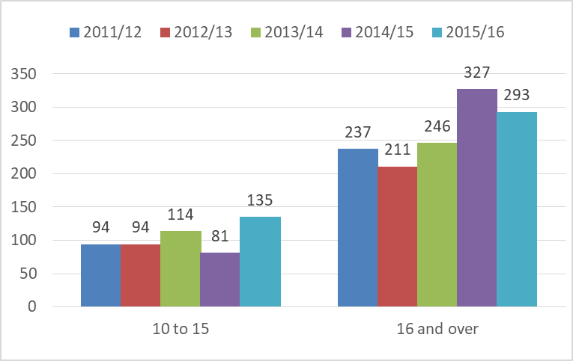

Source: SSD903 Extract from CRS.

Figure 10 shows the breakdown in broad ethnic groups of the children looked after as at 31. March 2016. The groupings are not as straightforward as they may appear. It should be noted that a high proportion of UASC are recorded as being from a White or White British background but are linked to the high number of UASC from Albania. Similarly a high proportion of UASC are recorded as being from an Asian or

Asian British background where they have come from Afghanistan.

Figure 10 – Children looked after at 31 March 2016 by ethnic origin

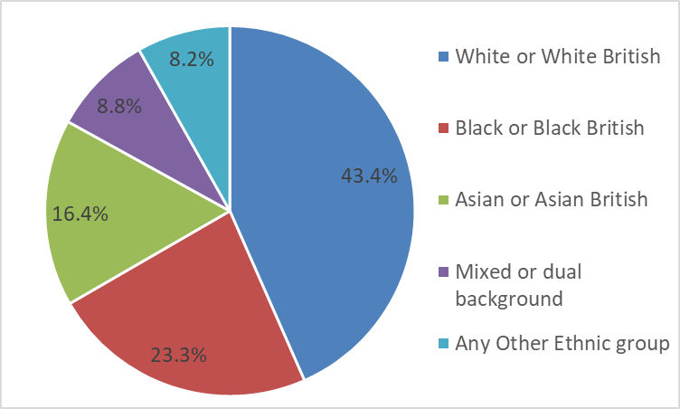

Source: SSDA903, Table LAA8.

The ethnic profile of the indigenous and UASC cohorts is very different in Croydon. Children from White or White British ethnic backgrounds and from Mixed or Dual ethnic backgrounds are overrepresented amongst indigenous looked after children.

The ethnic profile of UASC changes significantly over time according to the changing nationalities of children seeking asylum.

Figure 11 shows that the majority of indigenous looked after children in Croydon are looked after because of abuse or neglect. Abuse or neglect is also the most common need for looked after children nationally.

Figure 11 – Indigenous children who started to be looked after during 2015/16 by category of need 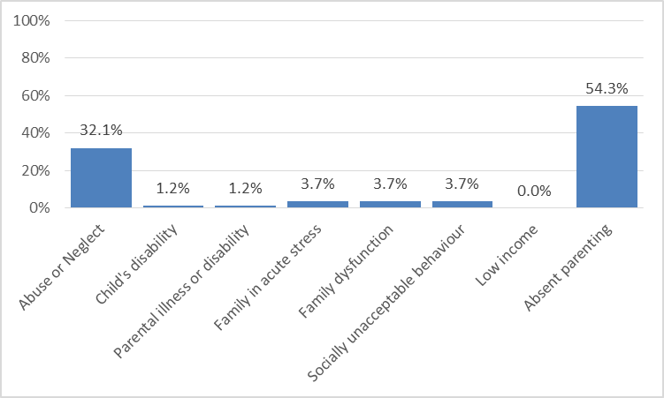

Source: SSDA903, Table LAC4.

Figure 12 shows the legal statuses of indigenous children who were looked after in Croydon in 2015/16. The majority of these children were looked after under a care order or section 20. In London and nationally for the same period, the proportion of S.20 was around 60%.

Figure 12 – Indigenous children looked after at 31 March 2016 by legal status (provisional)

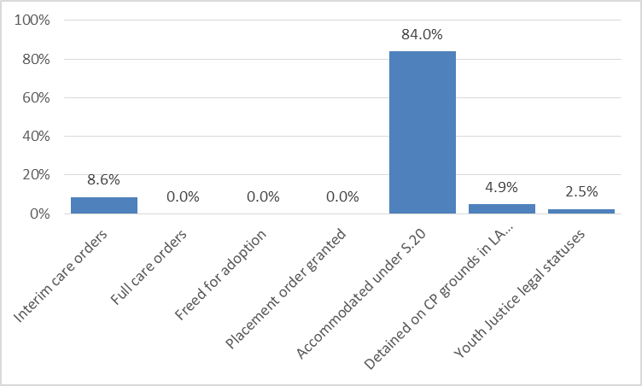

Source: SSDA903, Table LAC3.

Figure 13 shows that six in 10 care leavers were known to be in education, employment or training on 31. March 2016, an increase from 2015. Whereas, the regional and national rates for this outcome for those 2 years has stayed constant.

Figure 13 – Percentage of children aged 19 years old who were looked after when they were 16 years old who were known to be in education, employment or training

Source: DfE LAIT - Looked After Children.

Around three quarters of care leavers were known to be in suitable accommodation on 31. March 2016, a similar proportion to 2013 and 2014.

Figure 14 - Percentage of children aged 19 years old who were looked after when they were 16 years old who were known to be in suitable accommodation

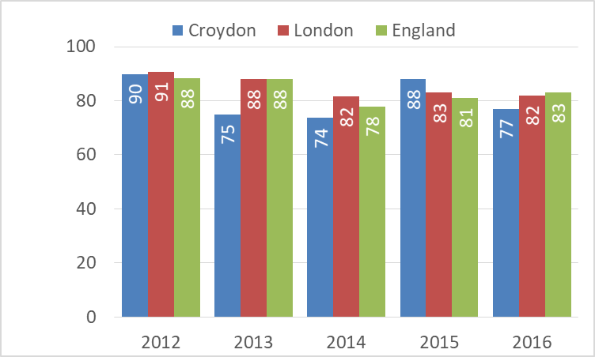

Source: DfE LAIT – Looked after Children.

**Adult safeguarding**

In 2017/2018 there were 2,585 individuals in Croydon involved in safeguarding concerns.[33] This number was an increase of over 500 on the previous year’s figure of 2,056.

Figure 15 highlights the vulnerability of the very elderly concerning safeguarding issues with nearly 7 in 10 (67.2%) of all safeguarding enquiries being concerned with those aged 85 years and over.

Figure 15 – Individuals involved in Section 42 safeguarding enquiries 2017/2018

Source : SAC,2017/2018, Annex C, Table 1

Table 1 shows that, by far the most common type of abuse in all cases that were concluded during 2017/2018 was ‘neglect and acts of omission’ which accounted for 27.0% of all abuse types. The next 3 types of abuse were “financial or material” (18.4%),“physical” (17.0%) and “psychological” (14.9%).

Over a half of alleged perpetrators of abuse (53.8%) were individuals known to the adult at risk but not related, or relatives or family carers. Service providers made up 36.5% of all the alleged abuse cases in 2017/2018 with 9.6% being alleged perpetrators unknown to the individual.

Table 1 - Concluded Section 42 enquiries by type of risk

|  |  |  |
| --- | --- | --- |
| **Type of Risk** | **Number** | **%** |
| Physical Abuse | 120 | 17.0% |
| Sexual Abuse | 40 | 5.7% |
| Psychological Abuse | 105 | 14.9% |
| Financial or Material Abuse | 130 | 18.4% |
| Discriminatory Abuse | * |  |
| Organisational Abuse | 40 | 5.7% |
| Neglect and Acts of Omission | 190 | 27.0% |
| Domestic Abuse | 50 | 7.1% |
| Sexual Exploitation | 5 | 0.7% |
| Modern Slavery | * |  |
| Self Neglect | 25 | 3.5% |
| TOTAL | 705 | 100% |

Source : SAC 2017/2018, Annex B, Table 2

**Adults receiving care**

**Requests for support**

During 2017/2018 there were 2,185 requests for support from new clients aged 18-64 years. This was much higher than the previous year’s figure of 1,505 requests. Figure 16 shows the outcomes of these requests.

Figure 16 – Top 5 outcomes of requests from new clients aged 18-64 in 2017/2018

Source: Table 10, SALT Data Return, 2017/2018.

Over the same period there were 4,760 requests for support from new clients aged 65 years and over. Again, this was many more than the 3,842 requests in the previous 2016/2017 year. Figure 17 shows the outcomes of these requests.

Figure 17 – Top 5 outcomes of requests from new clients aged 65 or over in 2017/2018

Source: Table 11, SALT Data Return, 2017/2018.

**Short-term support to maximise independence**

Older people clients with short term support care to maximise their independence made up one fifth (20.4%) of the total. For new younger adult clients aged 18-64 years, short term support to maximise independence accounted for only 7.1% of the total.

**No services or low level services provided**

No services were provided to 5.7% of the older aged clients (excluding the deceased). and 3.7% of the younger adults received no services. Around 13.0% of younger adult clients received ongoing low level support compared to 10.8% of the older clients (65+ years).

**Long-term support**

During 2017/2018, there were 2,145 clients aged 18-64 years and 3,010 clients aged 65 and over in receipt of long-term support in Croydon. These figures are both down on the previous year when there were 2,646 clients aged 18-64 and 4,205 clients aged 65 and over. Figures 18 and 19 show the primary support reason for these clients.

Figure 18 shows that physical support – personal care support was the primary support reason for 18.2% of clients aged 18-64. However, support for learning disability and mental health clients amounted to over 70% of the total support provided.

Figure 18 – Primary support reason for clients aged 18-64 in receipt of long-term support, 2017/2018

Source: Table 37, SALT Data Return, 2017/2018.

Figure 19 shows that physical support – personal care support was the primary support reason for 67.1% of all clients aged 65 years and over. This was by far the most common primary support reason for all older clients in receipt of long-term support in Croydon, in London and in England.

Figure 19 - Primary support reason for clients aged 65 and over in receipt of long-term support, 2017/2018

Source: Table 37, SALT Data Return, 2017/2018.

**Self-directed support and direct payments**

Only 10.2% of service users in Croydon received direct payments in 2017/2018. Across London 20.0% of service users received direct payments, similar to the national average of 21.9%.

**Carers**

The proportion of carers in Croydon receiving direct payments remains much lower than the regional and national averages. Only 14.5% received direct payments in Croydon compared to 24.0% across London and an average of 23.4 nationally.[34]

**Reablement**

The effectiveness of reablement services is measured by the percentage of over 65 year olds who remain in their own home 91 days after they have been discharged from hospital.

There has been improvement in the effectiveness of reablement services in Croydon since 2010/11.

In 2016/2017 approximately 91.38% of older people were still at home 91 days after discharge. During 2017/2018, the outcome has improved to 93.4%. This is much better than the Outer London average of 87.9%, the London average of 87.2% and the national average of 82.9%.

The following table provides more details on the people who benefitted from reablement in 2017/2018.

Table 2 – Number of older people still at home 91 days after discharge from hospital by age band.

|  |  |  |  |
| --- | --- | --- | --- |
|  | Number of discharges to rehabilitation where the intention is for the patient to go back home | Number of discharges above where person  was still at home 91 days later | % still at home 91 days after discharge |
| 65 to 74 years old | 60 | 55 | 91.7% |
| 75 to 84 years old | 123 | 116 | 94.3% |
| 85 years old and over | 148 | 138 | 93.2% |
| Total - 65 and Over | 331 | 309 | 93.4% |

Source: Table STS004, SALT Data Return, 2017/18.

**Residential and nursing care**

During 2017/2018, there were 163 adults who had their long-term support needs met by a change of setting to residential and nursing care. This excludes anyone who was transferred between residential and nursing care.

For adults aged 18-64 there were 8.0 admissions to residential and nursing care per 100,000 population in Croydon, compared to 9.6 per 100,000 in London. For older people aged 65 and over there were 280.2 admissions per 100,000 population in Croydon compared to 406.2 per 100,000 in London.

** Community Safety**

Areas of progress

* The total number of notifiable offences in Croydon has risen in recent years but the rate of offences committed in Croydon is lower than the London average.
* The number of gang flagged offences has decreased but there remains an issue around public perception of this issue.
* The number of hate crimes is decreasing.
* Croydon has moved from the 3rd highest rate of Domestic Abuse to the 10th highest in London.

Challenges

* Only 3 of the 7 MOPAC offences are performing better than in the previous year.
* Knife crime is still an issue with around 30% resulting in injury or death.
* The number of victims of serious youth violence is increasing.
* Higher rate of first time entrants to the criminal justice system than the London average.

**Overview**

Community safety remains a priority in Croydon. This section outlines the issues in the borough for key crime types and fly-tipping.

* Total notifiable offences
* MOPAC 7
* Gang crime and serious youth violence
* Knife crime
* Hate crimes
* Domestic abuse and sexual violence
* Antisocial behaviour
* Youth offending
* Adult offending

**Crime**

**Total notifiable offences**

The overall number of offences committed in Croydon has fallen in recent years based on the last 10 financial years of reporting as seen in Figure 1.

There is a high number of offences in Croydon but the borough has one of the largest populations in London which means that the overall rate of offences per 1,000 population in Croydon is not as high as other parts of London.

Figure 1 – Total notifiable offences

Source : MPS

Figure 2 shows that the rate of total notifiable offences in Croydon is in the bottom third of lowest rates across London. In fact, there are 11 inner London Councils are amongst those with the highest rates.

Croydon, together with 20 other London Councils, has a lower rate of TNOs than the London average. This suggests that it is only a few inner London Councils such as Westminster, Camden, Kensington and Chelsea and Islington, with high rates, that are bringing up the London average.

Figure 2 – Rate of total notifiable offences per 1,000 resident population – October 2018

Source : MPS, Borough Volume and Trends dashboard

**MOPAC 7**

The former 7 performance indicators from the Mayor’s Office for Policing and Crime (MOPAC) were monitored against targets set in terms of percentage reduction in the number of offence types compared to a 2012 baseline.

In March 2016, the MOPAC 7 were no longer monitored in the same way. The new London Mayor introduced a new Crime Plan. The indicators are still reported on a rolling 12 months basis but are measured against the average for each rolling 12 month period.

For this report, the original MOPAC 7 will continue to be followed as they cover a range of criminal offences that affect the community in Croydon.

The original 7 included burglary, criminal damage, robbery, theft from vehicles, theft of a vehicle, theft from a person and violence with injury. The latter is no longer available in the public domain so common assault will be reported instead.

Figure 3 shows that the number of theft from vehicle offences has started to rise and is higher than the same period in the previous year and is also above the average in the previous year. The latest figure for the rolling 12 months to the end of October 2018 shows that there have been 2,390 theft from vehicle offences in Croydon.

Figure 3 – Number of Theft from vehicle offences

Source: MPS, Borough Volume and Trends dashboard

Figure 4 shows that the number of theft of motor vehicle offences has been consistently around the 1,100 level over the last 18 months. The latest 12 months rolling figure to end of October 2018 has seen a slight increase to 1,154 of these offences. There are more CCTV cameras dotted around the borough so these may help as a deterrent. Also, drivers are using their own car cameras which also would deter people from breaking into vehicles.

Figure 4 – Number of Theft of motor vehicle offences

Source: MPS, Borough Volume and Trends dashboard

Figure 5 shows that the number of robbery offences in Croydon has gone down on the same period last year. The last 7 rolling 12 months show that the number of robberies has stabilised at around 1,000. This is a positive start and it will be interesting to see if it continues the same for the rest of the year.

Figure 5 – Number of Robbery offences

Source: MPS, Borough Volume and Trends dashboard

Figure 6 shows that the number of Burglary offences in Croydon has stayed at similar levels in the past 18 months. However, the average number in the first 7 months of 2018/2019 is higher than the average for the first 7 months in the previous year. The number is also higher than the average for the whole of 2017/2018.

With winter on the horizon and a shorter amount of day light, the number of these offences could still increase further.

Figure 6 – Number of Burglary offences

Source: MPS, Borough Volume and Trends dashboard

The number of criminal damage offences has been dropping over the past 18 months. The latest position shows that the numbers of these offences in Croydon are continuing to reduce. The latest figure of 2,722, for the rolling 12 months to 31. October 2018, continues a downward trend for the borough.

Figure 7 – Number of Criminal damage offences

Source: MPS, Borough Volume and Trends dashboard

The number of theft from person offences is increasing. In the first 7 months of 2018/2019, the numbers have increased on last year’s levels. The latest 7 months average of 555 is already over 40 more than the average of 513 for whole of last year.

Figure 8 – Number of Theft from person offences

Source: MPS, Borough Volume and Trends dashboard

Data for the last of the MOPAC 7 : Violence with Injury, is not available on the MOPAC dashboard. As an alternative, the number of common assaults is being tracked. The average number of these offences in the first 7 months of 2018/2019 is 2,996 which is almost the same as the previous year’s average of 2,997.

Figure 9 – Number of Common assaults

Source: MPS, Borough Volume and Trends dashboard

**Gang crime and serious youth violence**

**Gang Crime**

The data on gang flagged offences for the rolling year to December 2017 has seen a slight rise to 34 in Croydon. Only the neighbouring boroughs of Lambeth (64) and Southwark (39) have a higher number of these offences.

Figure 10 - Number of gang flagged offences

Source: MOPAC Gangs dashboard

**Serious Youth Violence**

Serious youth violence covers offences where serious violence is committed against a young person. This is an increasing issue in Croydon which has the largest youth population in London.

The number of victims of serious youth violence has increased slightly in recent years.

Figure 11 – Number of victims of serious youth violence

Source: MOPAC Gangs dashboard

**Knife Crime**

The MOPAC Weapon enabled crime dashboard defines knife crime as “all offences of murder, attempted murder, threats to kill, manslaughter, infanticide, wounding or carrying out an act endangering life, GBH without intent, ABH and other injury, sexual assault, rape, robbery where a knife or sharp instrument has been used. The definition excludes simple possession i.e. when a police search results in a discovery of possession of a weapon.

Knife crime with injury constitutes a knife crime that has been committed in which the victim has received any form of injury because of the incident.

Figure 12 shows that during the 12 months to 30. September 2018, there were 593 knife crimes in Croydon. Of these 180 (30.4%) resulted in injuries. The 593 offences made up 3.7% of all knife crimes in London (i.e. all the 33 London councils).

Figure 12 – Number of Knife Crimes in Croydon – Rolling 12 months up to 30. September 2018

Source : MOPAC, Weapon enabled crime dashboard

**Hate crime**

The Hate Crime dashboard monitors the offending throughout the Metropolitan Police Service Boroughs. It includes data on victimisation, perpetrators/offenders identified and the overall public perception and victim satisfaction of those affect by hate crime.

A hate crime is defined as “any incident that is perceived by the victim or any other person to be racist, homophobic, transphobic or due to a person’s religion, belief, gender identity or disability”[35]

All hate crime types are reported on a rolling 12 month basis so the monthly figures reported are not separate month figures but a sum of the 12 months leading to any given month.

The under-reporting of all types of hate crime remains a national issue. Figure 13 shows that in Croydon there has been a decrease in the number of reported hate crimes in recent years. In fact, every rolling 12 month period in 2018/2019 has shown an average reduction of over 16% in the number of hate crimes reported compared to the same periods in the previous year.

Figure 13 - Total recorded hate crimes

Source: MOPAC Hate Crime Dashboard

More recently, the majority of reported hate crimes in Croydon have been racist and then disability hate crimes. Racist hate crime has been recorded for longer than others so there is likely to be a better reporting rate for racist crimes.

Figure 14 shows that the number of race hate crimes have dropped to below the rates of the previous year. This is encouraging but the actual number has still been over 500 in every rolling12 month period.

Figure 14 – Total Racist hate crime

Source: MOPAC Hate Crime Dashboard

Figures for disability hate crime in Croydon shows that the number had been dropping throughout 2017/2018 and is now stabilising at around the low 400 mark. The current year’s performance so far is showing a consistent monthly decline in the numbers reported on the previous year.

Figure 15 – Disability hate crime

Source : MOPAC Hate Crime Dashboard

The number of faith hate crimes has been falling in Croydon over the past 18 months as Figure 16 shows. The average number of hate crimes, for the 12 months rolling to any given month in 2017/2018 was 65. The average for the first 7 months of this financial year to October 2018 is 59.

Figure 16 – Faith hate crime

Source : MOPAC Hate Crime Dashboard

The numbers of Islamophobic hate crimes have been reported following concerns about an increase nationally in this type of hate crime. The latest figures are showing a decreasing trend compared to last year with 35 reported during the 12 months to October 2018. The number was much higher at 58 for the same period last year.

Figure 17 – Islamophobic hate crime

Source : MOPAC Hate Crime Dashboard

All the uncertainty around BREXIT has contributed to a rise in the presence of nationalist groups and this, in turn, has led to a rise in the number of anti-semetic incidents reported to the Police.

Figure 18 shows that the number of these types of hate crime in Croydon has been increasing but fortunately, the numbers reported are still quite low with 6 being the most reported in any given 12 month rolling period.

Figure 18 – Anti-semetic hate crime

Source : MOPAC Hate Crime Dashboard

There has been quite a high number of sexual orientation hate crimes reported to the MPS in Croydon each year. The figures have risen from a base of around 20-30 crimes in 2012/2013 and 2013 to a figure of 52 in the 12 rolling months to 31.October 2018. The positive message is that the number is lower than the 58 reported over the same period last year.

Figure 19 - Sexual orientation hate crime

Source : MOPAC Hate Crime Dashboard

Figure 20 shows that Croydon has seen a reduction in the number of hate crimes aimed at its transgender population.

Figure 20 – Transgender hate crime

Source : MOPAC Hate Crime Dashboard

**Domestic abuse and sexual violence**

The Domestic and Sexual Violence dashboard has been developed from the Mayor’s Violence Against Women and Girls Strategy. It monitors the offences across London recorded by the Metropolitan Police Service.

**Domestic abuse**

Croydon is in the top third of London councils for domestic abuse with a rate of 18 per 1,000 of population for the 12 months rolling to 30. September 2018. Behind Barking and Dagenham, Greenwich, Tower Hamlets, Haringey, Hounslow,

Newham, Hackney, Lewisham and Islington.

Of the total victims of domestic abuse in Croydon, 76% were female. One in 3 (32%) of those subjected to domestic abuse were in the 25-34 year age band. 22% were in the 35-44 year band and 19% were in the 18-24 year band.

Of the victims, 48% were from the White community, 30% were from the Black community, 10% were from the Asian community and 10% were of unknown ethnic origin.

Table 1 – Domestic Abuse - 12 months rolling to September 2018

|  |  |  |
| --- | --- | --- |
|  | Number | Rate per 1,000 pop. |
| Domestic Abuse Incidents | 141,229 | 18.0 |

Source : MOPAC DV and Domestic and Sexual Violence Dashboard

**Sexual Violence**

The total number of Sexual violence crimes is made up of rape offences and other sexual offences.

The latest figures show that there have been 422 sexual violence crimes reported in Croydon which equates to a rate of 1.1 per 1,000 of population.

Table 2 – Sexual Violence - 12 months rolling to September 2018

|  |  |  |
| --- | --- | --- |
|  | Number | Rate per 1,000 pop. |
| Rape Offences | 422 | 1.1 |
| Other Sexual Offences | 514 | 1.3 |
| Total Sexual Offences | 936 | 2.4 |

Source : MOPAC DV and Domestic and Sexual Violence Dashboard

Of the total victims of sexual offences in Croydon, 86% were female. Over half (53%) were aged under 24 years of age.

Of the victims, 51% were from the White community, 24% were from the Black community, 8% were from the Asian community and 16% were of unknown ethnic origin.

41% were victims of rape and 59% were victims of other sexual offences.

**Antisocial behaviour**

Despite a recent fall in the number of antisocial behaviour (ASB) incidents recorded in Croydon, the number was still over 8,000 as at 31st March 2018.

The most common types of antisocial behaviour reported to the Police were rowdy or inconsiderate behaviour and malicious or nuisance communications. Communal area nuisance and harassment were the most common antisocial behaviour reported to the council.[36]

Figure 21 – Reported ASB in Croydon

Source : Safer Croydon Partnership

**Youth Offending**

In Croydon, there is a greater proportion of youth offenders, aged 10-17 years, who were from BAME backgrounds (62.5%). This was slightly above the proportion of BAME offenders in London (61.5%). The proportion for England and Wales was only 24.1% for the same period.

Figure 22 - The percentage of children and young people in the youth justice system who received a youth caution or court conviction for the year ending March 2017

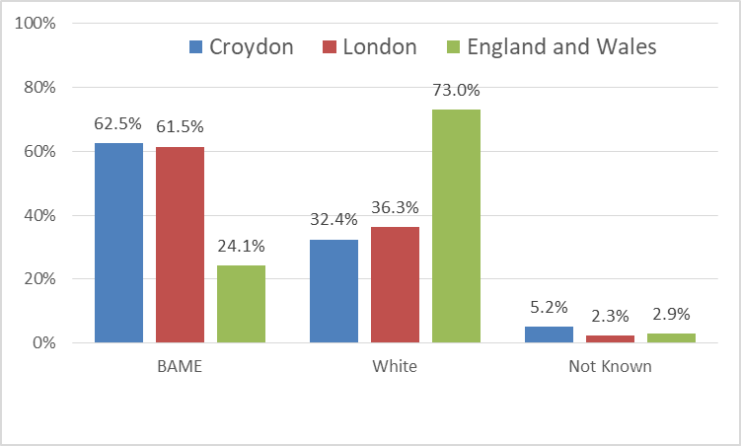

Source: Youth Justice Board

There continues to be a disproportionately high percentage of young people from a Black or Black British background amongst the first time entrants in Croydon.

The most common offences committed by first time entrants in Croydon are violence against the person, drug offences and theft and handling.

**Adult and Juvenile Re-Offending**

Over the past few years, there has been an increase in the number of offenders of both adult and juvenile age. Conversely, re-offending rates have been decreasing. From 2012/2013 to 2015/2016 the proportion of adult offenders who reoffend has steadily been dropping from 30.2% to 26.6%. This downward trend has been the same for juveniles with a change from 51.9% to 49.2% over the same period.[37]

** Environment and transport**

Areas of progress

* Carbon dioxide emissions continue to fall.
* Croydon has one of the highest rates for the reuse, recycling and composting of household waste in London.
* The number of road traffic collisions in Croydon has increased for the second year running.

Challenges

* The number of road users killed or seriously injured (KSI) in Croydon has increased again.

**Overview**

This section looks at a range of issues relating to the environment and transport including waste and method of travel to work.

* Environment
* Transport
* Substance Misuse
* Fire Services
* Fly-tipping

**Environment**

**Waste**

Croydon is average compared to the rest of the London authorities for the amount of household waste collected per person as shown in Figure 1. In Croydon 355.3 kg was collected per person in 2016/2017.

Figure 1 – Collected household waste collected per person (kg) 2016/2017

Source: Defra, Table 3 - Local authority collected waste statistics, 2016/2017.

Croydon is in the top quarter of London boroughs for reuse, recycling and composting. In 2016/17, 38.6% of household waste was recycled in Croydon compared to the national average of 43.7% and the London average of 33.0%.

Figure 2 – Percentage of household waste sent for reuse, recycling or composting 2016/2017

Source: Defra, Table 3 - Local authority collected waste statistics, 2016/2017.

However Croydon sent 53.8% of its municipal waste to landfill. This is much higher than the 15.9% national average. The national average is influenced by the higher incineration rates in other local authorities.

**Air quality**

Carbon dioxide emissions in Croydon have fallen steadily from 5.2 tonnes per person in 2005 to just 2.9 tonnes per person in 2016.

The amount of CO2 produced from domestic, industrial and commercial, and transport sources have all decreased slightly over the 2005 to 2016 period.

This is part of a wider regional and national trend. In London emissions dropped from 6.3 tonnes per person in 2005 to 3.6 tonnes per person in 2016. Across England emissions fell from 8.7 to 5.4.[38] The London Borough of Croydon Air Quality Action Plan, 2012-2017 predicts that the CO2 emissions will continue to drop beyond 2025.

**Transport**

**Travel to work**

According to the 2011 Census, Croydon is a net exporter of workers. 54.8% of the 88,300 people who were recorded as working in Croydon in 2011 also lived in Croydon. However, this cohort only accounted for 34.4% of the 140,600 Croydon

residents whose place of work was recorded. The main methods of transport to work varied between those who lived

and worked in Croydon : those who lived in Croydon but worked outside of the borough, and those who lived outside of the borough but worked in Croydon.

Most of those people who worked in Croydon and also lived within the borough drove to work in a car or van, caught a bus, minibus or coach or walked to work, as Figure 3 shows.

Figure 3 – Method of travel to work for those who lived and worked in Croydon

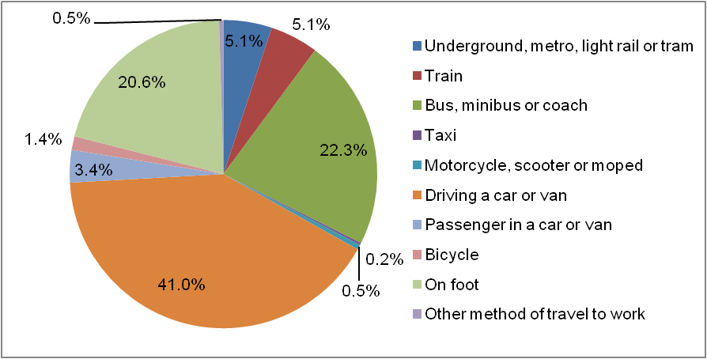Source: ONS 2011 Census Table WU03UK

The method of travel to work for workers commuting in from outside of the borough was slightly different as can be seen from Figure 4. Nearly half of these workers drove to work in a car or van. Considerably more workers used trains to commute in and far fewer walked to work.

Figure 4 – Method of travel to work for those who lived outside of the borough but worked in Croydon

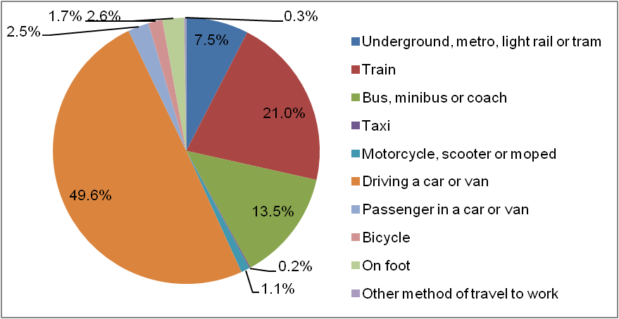

Source: ONS 2011 Census Table WU03UK

Figure 5 shows the main areas of residence for Croydon workers who lived outside of the borough. These areas include other London boroughs as well as districts in Surrey and Sussex.

Figure 5 – Main areas of residence for Croydon workers who lived outside of the borough

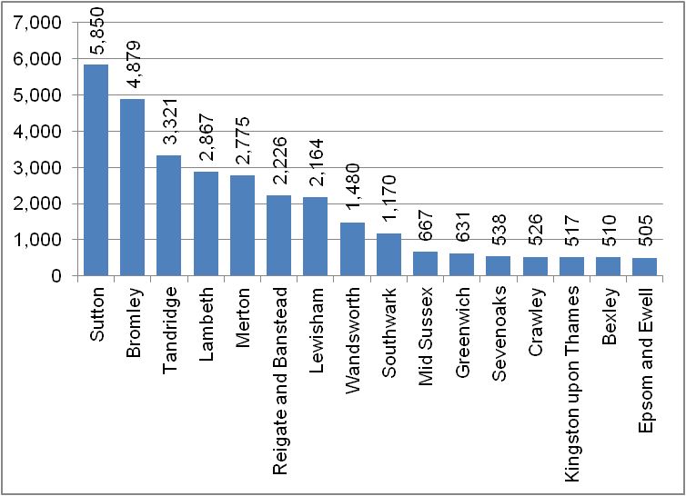

Source: ONS 2011 Census Table WU03UK

For those Croydon residents who worked outside of the borough, train was the most common method of transport. Driving a car or van was less common but was still the main method of transport for nearly a third of these residents.

Figure 6 – Method of transport to work for Croydon residents working outside of the borough

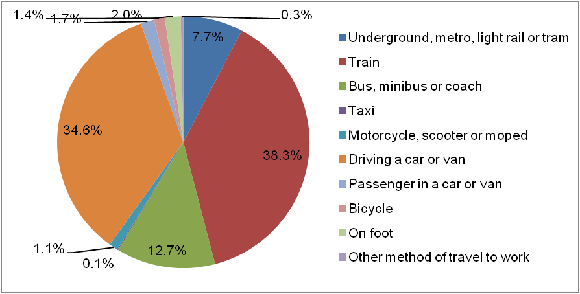

Source: ONS 2011 Census Table WU03UK

The majority of Croydon residents who work outside of the borough are commuting to other London boroughs as shown by Figure 7. This may explain the differences in the main mode of transport used by this cohort. Please note that Westminster and the City of London were merged by the Office for National Statistics for this dataset.

Figure 7 – Main places of work for residents who worked outside of the borough

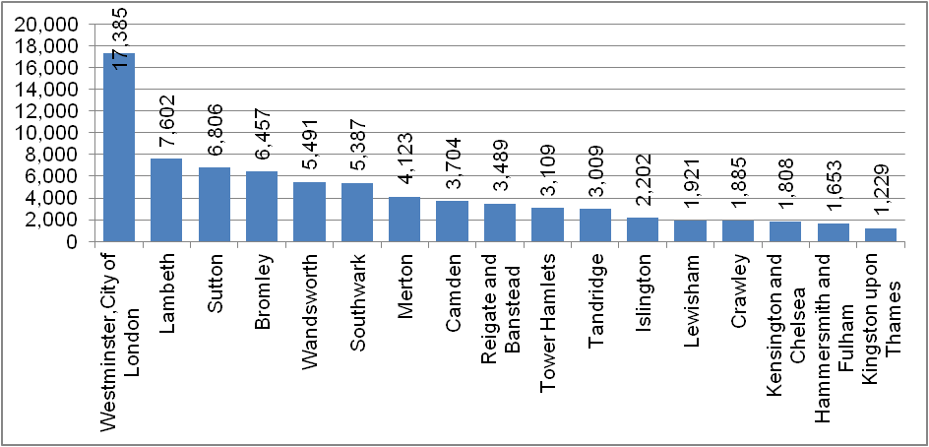

Source: ONS 2011 Census Table WU03UK

**Walking and cycling**

Although a significant proportion of Croydon residents who worked locally walked to work, the figures above show only a very small proportion of residents cycled to work. The Department for Transport collects statistics about general walking and cycling activity.

In the latest figures for 2014/2015 it was estimated that about 88.8% of residents in Croydon walked for over 10 minutes at least once a month. This was similar to the London average of 89.0% and the England average of 86.3%[39].

The proportion of Croydon residents estimated to have cycled at least once a week during 2016/2017 was 7.6% compared to the London average of 12.6% and the national average of 11.9%. The Croydon and London figures are down on the previous year.[40]

**Availability of a car or van**

The availability of a car or van in a household is often used as a proxy measure for how well households can access services and their wider community. In Croydon about a third of households in the 2011 Census were recorded as not having a car or van.

The 2021 Census may show a different picture as more younger adults may be staying at home - not being able to afford to move out – but being able to afford to buy cars instead of homes.

However, there is a clear pattern across London with households in Inner London being less likely to have a car or van than those in Outer London boroughs. It is likely that the good public transport links in Croydon influence these figures.

Figure 8 – Percentage of households without a car or van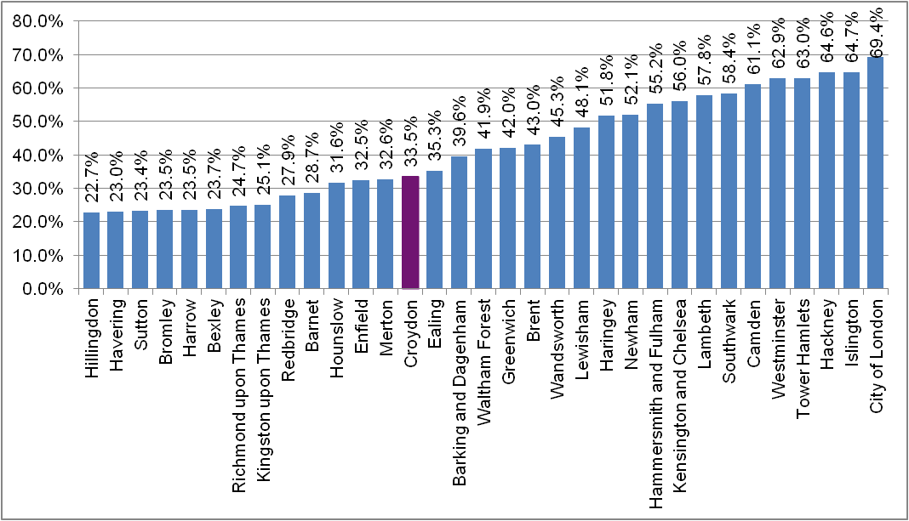

Source: ONS 2011 Census Table KS404EW

**Road Traffic Collisions**

The number of road traffic collisions in Croydon has fluctuated over the last five years as shown by Figure 9. The 981 collisions in 2014 has been the highest number recorded over the last 5 years to 2017. The majority of these collisions only involve slight injuries. There have been 5 fatalities in Croydon in both 2016 and 2017.

Figure 9 – Number of road traffic collisions

Source: DfT Road casualty statistics Table RAS10016

The number of road users killed or seriously injured (KSI) in Croydon in 2013 numbered 71. The latest figure for 2017 is 124 which has topped the highest figure of 107 in 2012.

Figure 10 shows the number of KSI casualties recorded over the past five years by the type of road user affected. For 2017 most casualties were pedestrians (41) followed by motor cyclists (39) and then cars (23).

Figure 10 – Number of KSIs by type of road user

Source: DfT Road casualty statistics Table RAS30043

**Fire Services**

The number of arson incidents reported in Croydon every June for the past 5 years has averaged around 323 for that month. The latest June 2018 number is down on the last 12 months at 332 incidents. Of these, only 1 in 4 (23.2%) were for real fires. Special services which include services such as lift rescues made up 29.8% of all reported arson incidents in Croydon in June 2018. Around a half (47.0%) were false alarms, predominantly from automated fire alarm systems.

Figure 11 – Reported Fires in Croydon in the Month of June from 2013-2018

Source : LFB.

**Fly-tipping**

24,797 fly-tipping incidents were recorded in 2016/17; this is an increase from the 18,560 recorded in 2014/15. This may be due in part to the campaign to encourage the public to report fly-tipping.

These latest figures place Croydon in the top 3 out of all London boroughs as can be seen from Figure 16.

Figure 12 – Number of fly-tipping incidents 2016/2017

Source: DEFRA, ENV24

1. ONS Integrated Household Survey Jan-Dec 2014 and ONS mid year population estimates 2014.
2. Gender Identity and Research Society (2011) Collecting Information on Gender Identity <http://www.gires.org.uk/GID8301.PDF>
3. MOPAC crime dashboard
4. ONS, Inter Departmental Business Register (IDBR).
5. GLA Report on Housing Characteristics, October 2013.
6. DCLG Live Tables on Dwelling Stock Table 615
7. croydon.gov.uk/contents/departments/planningandregeneration/pdf/912686/917223/localhousingmarketassessment
8. GLA Net additional dwellings, total dwellings, and persons per dwelling, Borough, 2015
9. Homelessness Review and Strategy 2018.
10. PHE, [Child Health Profiles](https://fingertips.phe.org.uk/profile-group/child-health) (based on data submitted to PHE)
11. PHE, [Public Health Outcomes Framework](https://fingertips.phe.org.uk/profile/public-health-outcomes-framework) (based on NHS Cover of Vaccination Evaluated Rapidly (COVER) data)
12. PHE, [Public Health Outcomes Framework](https://fingertips.phe.org.uk/profile/public-health-outcomes-framework) (based on data submitted to the ImmForm website)
13. PHE, [NCMP Profiles](https://fingertips.phe.org.uk/profile/national-child-measurement-programme) (based on National Childhood Measurement Programme data)
14. PHE, [NCMP Profiles](https://fingertips.phe.org.uk/profile/national-child-measurement-programme) (based on National Childhood Measurement Programme data)
15. PHE, [Sexual Health Profiles](https://fingertips.phe.org.uk/profile/sexualhealth) (based on ONS conception statistics)
16. ONS, [Conception Statistics](https://www.ons.gov.uk/peoplepopulationandcommunity/birthsdeathsandmarriages/conceptionandfertilityrates/datasets/conceptionstatisticsenglandandwalesreferencetables)
17. PHE, [Sexual Health Profiles](https://fingertips.phe.org.uk/profile/sexualhealth) (based on DH abortion statistics)
18. PHE, [Sexual Health Profiles](https://fingertips.phe.org.uk/profile/sexualhealth) (based on ONS conception statistics)
19. ONS, [Conception Statistics](https://www.ons.gov.uk/peoplepopulationandcommunity/birthsdeathsandmarriages/conceptionandfertilityrates/datasets/conceptionstatisticsenglandandwalesreferencetables)
20. PHE, [Sexual Health Profiles](https://fingertips.phe.org.uk/profile/sexualhealth) (based on submissions to PHE)
21. PHE, [Sexual Health Profiles](https://fingertips.phe.org.uk/profile/sexualhealth) (based on submissions to PHE)
22. PHE, [Public Health Profiles](https://fingertips.phe.org.uk/profile/health-profiles) (based on the Active Lives survey, Sport England)
23. PHE, [Public Health Outcomes Framework](https://fingertips.phe.org.uk/profile/public-health-outcomes-framework) (based on data submitted to the ImmForm website)
24. ONS, [Estimates of Personal Wellbeing](https://www.ons.gov.uk/peoplepopulationandcommunity/wellbeing/bulletins/measuringnationalwellbeing/april2016tomarch2017) (based on the Annual Population Survey, ONS)
25. ONS, [Estimates of Personal Wellbeing](https://www.ons.gov.uk/peoplepopulationandcommunity/wellbeing/bulletins/measuringnationalwellbeing/april2016tomarch2017) (based on the Annual Population Survey, ONS)
26. PHE, [Public Health Profiles](https://fingertips.phe.org.uk/profile/health-profiles) (based on the Enhanced Tuberculosis Surveillance system)
27. PHE, [Public Health Outcomes Framework](https://fingertips.phe.org.uk/profile/public-health-outcomes-framework) (based on Hospital Episodes Statistics)
28. NDTMS Profiles
29. PHE, [Public Health Profiles](https://fingertips.phe.org.uk/profile/health-profiles) (based on ONS health-state life expectancies)
30. PHE, [Public Health Profiles](https://fingertips.phe.org.uk/profile/health-profiles) (based on ONS births and deaths data)
31. PHE, [Local Tobacco Control Profiles](https://fingertips.phe.org.uk/profile/tobacco-control) (based on ONS mortality data)
32. PHE, [Public Health Outcomes Framework](https://fingertips.phe.org.uk/profile/public-health-outcomes-framework) (based on ONS mortality data)
33. Safeguarding Adults Collection (SAC), 2017/2018
34. HSICS ASCOF
35. MOPAC Hate crime dashboard
36. Croydon Strategic Assessment 2013 p22-23.
37. Ministry of Justice, Proven re-offending overview data tool.
38. DECC, UK local authority and regional carbon dioxide emissions national statistics: 2005-2016, updated 2018
39. Dft Walking and Cycling (local authority level), Table CW0105
40. DfT Walking and Cycling Statistics, Table CW0302