IMD 2015 – Education Skills and Training Deciles
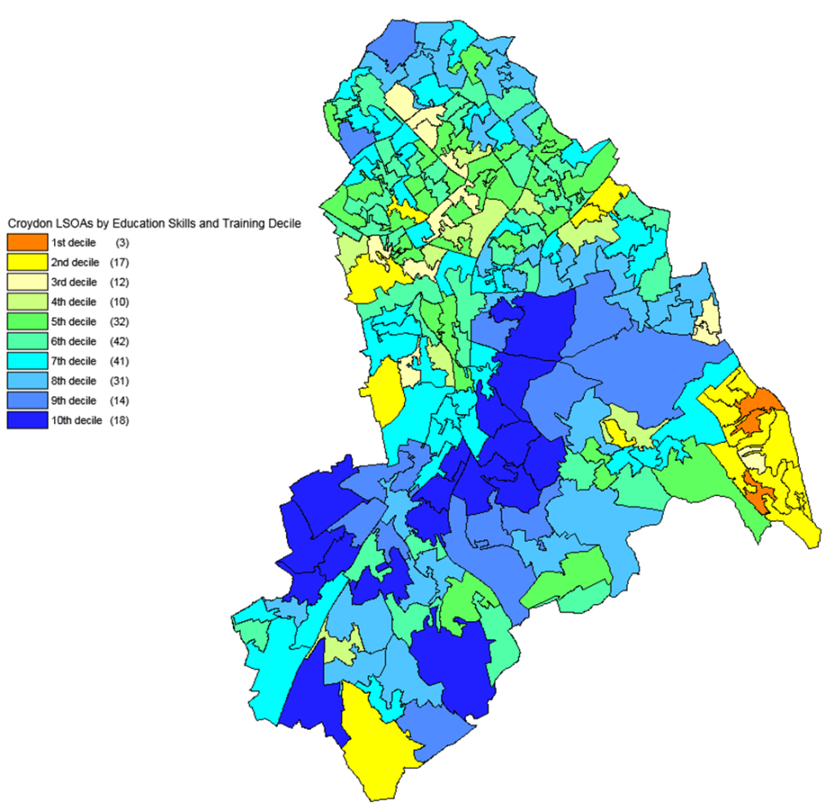
Source: DCLG and Ordnance Survey (Crown Copyright)

